2017 M. ANGLŲ KALBOS KONKURSAS (9–10 KL.)

ENGLISH LANGUAGE CONTEST 2017 (FORMS 9-10)

- Konkurso užduočių struktūra (1 lapas)
- Pasirengimas (1 lapas)
- Rekomenduojamų video prezentacijų sąrašas (1 lapas)
- Vertinimo kriterijai (anglų kalba) (3 lapai)
  - Rašinio / straipsnio
  - Monologo / pasisakymo
  - Dialogo / diskusijos
- Užduotis raštu (5 lapai)
- Užduotys žodžiu
  - Monologas / Pasisakymas (10 lapų)
  - Dialogas / Diskusija (10 lapų)

KONKURSO UŽDUOČIŲ STRUKTŪRA
UŽDUOTIES TIPAS | UŽDUOTYS | TAŠKAI | LAIKAS
RAŠTU | Rašinys / Straipsnis.  Minimalus žodžių skaičius – 250.  Rašymo užduotis atliekama pažiūrėjus trumpą video prezentaciją.  Prezentacija žiūrima du kartus. | 15 | Video prezentacijos peržiūrai (2 kartus) skiriama apie 20 min.  Rašymui skiriama iki 60 min.  Iš viso apie 80 min.
ŽODŽIU | Monologas:  Pasisakymas aptariant lietuvišką patarlę. | 15 | Pasirengimui skiriama 2-3 min.  Pasisakymui skiriama 1-2 min.  Iš viso mokiniui iki 5 min.
 | Dialogas:  Diskusija aptariant perskaitytą naujienų tekstą. | 15 | Pasirengimui skiriama 2 min.  Diskusijai skiriama 3 min.  Iš viso 5 min. mokinių porai.
IŠ VISO |  | 45

KOMANDINĘ UŽDUOTĮ rajono (miesto) komisija organizuoja savo nuožiūra.

Ši užduotis vertinama neformaliai. Rekomenduojamos užduotys:

LOBIŲ PAIEŠKA IR PRISTATYMAS

Temos: Mano miestas / Mano regionas.

Potemės: Vietovės / Žmonės / Renginiai.

Formatai: skelbimas, skrajutė, plakatas, eilėraštis, daina, vaidybinis etiudas, skaidrių šou, filmukas.

Užduoties pavyzdžiai::
- Sukurkite skaidrių šou „Aplankykite mano miestą“.
- Sukurkite vaidybinį etiudą „Susipažinkite su mano miesto žmonėmis“.
- Sukurkite skelbimą „Kviečiame į miesto tradicinius renginius“.
- Sukurkite eilėraštį / dainą „Mano miestas – pats šauniausias“.

PROTŲ MŪŠIS

Temos: Anglakalbės šalys / Europos šalys / Lietuva ir jos kaimynės.

Formatai: Protų mūšis su vaizdine megžiaga / be vaizdinės medžiagos.

PASIRENGIMAS
UŽDUOTYS |  | LAPAI | PASIRENGIMAS
RAŠTU | Viršeliai kodavimui. | 2 lapai | - Parengti kopijas kiekvienam mokiniui.  - Surašyti kodus prieš išdalijant užduotis dalyviams.  - Surinkti pirmuosius viršelius su dalyvių pavardėmis.
 | Rašinys / Straipsnis.  Rašymo užduotis atliekama pažiūrėjus trumpą video prezentaciją.  Prezentacija žiūrima du kartus. | 1 lapas – užduotis ir vieta užrašams.  1 lapas – juodraštis.  1 lapas – švarraštis.  1 lapas – vertinimo lentelė. | - Pasirinkti video prezentaciją iš rekomenduojamų.  - Siekiant išvengti interneto trikdžių olimpiados dieną, patartina video prezentaciją išsaugoti laikmenoje.  - Parengti užduoties kopijas dalyviams.  - Parengti vertinimo lentelės kopijas – tiek kopijų, kiek mokinių. Vertintojai apveda balų skaičių pagal kiekvieną kriterijų, o bendrą balą įrašo apačioje. Pasibaigus olimpiadai, vertinimo lenteles galima atiduoti mokiniams.
ŽODŽIU | Monologas : | 10 užduočių lapų su skirtingomis patarlėmis.  1 lapas – vertinimo lentelė. | - Pasirinkti norimas patarles.  - Parengti užduočių kopijas dalyviams ir vertintojams.  - Parengti vertinimo lentelės kopijas – tiek kopijų, kiek mokinių. Vertintojai apveda balų skaičių pagal kiekvieną kriterijų, o bendrą balą įrašo apačioje. Po konkurso vertinimo lenteles galima atiduoti mokiniams.
 | Dialogas:  Diskusija pagal perskaitytą naujienų tekstą. | 5 užduočių komplektai (Mokiniui A ir Mokiniui B).  1 lapas – vertinimo lentelė. | - Parengti užduočių komplektų kopijas dalyviams ir vertintojams.  - Parengti vertinimo lentelės kopijas – tiek kopijų, kiek mokinių. Vertintojai apveda balų skaičių pagal kiekvieną kriterijų, o bendrą balą įrašo apačioje. Pasibaigus olimpiadai, vertinimo lenteles galima atiduoti mokiniams.

REKOMENDUOJAMOS VIDEO PREZENTACIJOS
Atsidarykite www.youtube.com ir paieškos laukelyje įveskite:

Why I Don’t Use A Smart Phone | Ann Makosinski | TEDxTeen (11:57)

ARBA

Atsidarykite šią nuorodą:

http://www.tedxteen.com/talks/why-i-dont-use-a-smart-phone-ann-makosinski

Atsidarykite www.youtube.com ir paieškos laukelyje įveskite:

Why I live a zero waste life | Lauren Singer | TEDxTeen (13:30)

ARBA

Atsidarykite šią nuorodą:

http://www.tedxteen.com/talks/why-i-live-a-zero-waste-life-lauren-singer

ARTICLE ASSESSMENT SCALE
CRITERIA | SCORE | DESCRIPTORS
Content | 3 | All / Major content points covered. Thorough and extensive coverage.
 | 2 | Some major content points covered. Adequate and sufficient coverage.
 | 1 | Too few content points covered. Insufficient coverage. Some irrelevant material.
Organisation | 3 | Ideas effectively organized. A variety of linking devices.
 | 2 | Ideas adequately organised. Simple linking devices.
 | 1 | Lack of organisation or linking devices.
Range of vocabulary and structure | 3 | Wide / Good range of structure and vocabulary.
 | 2 | Adequate range of structure and vocabulary.
 | 1 | Limited / Narrow range of structure and vocabulary.
Accuracy  (vocabulary, grammar, spelling, punctuation) | 3 | No errors / minimal errors.
 | 2 | A number of errors, but they do not obscure communication.
 | 1 | Frequent errors, some of which may obscure communication.
Appropriacy of register | 3 | Consistent use of neutral / semi-formal register.
 | 2 | Inconsistent use of neutral / semi-formal register.
 | 1 | Little awareness of register.
Total  (out of 15) |  | ASSESSOR’S SIGNATURE AND COMMENT

NOTES
- Length – minimum 250 words. If the text is shorter, the final score is adjusted as agreed by the evaluation committee.
- Spelling – British and American varieties are acceptable.
- Contractions are acceptable.

INDIVIDUAL TALK based on a proverb
ASSESSMENT SCALE
SCORE |  | DESCRIPTORS
Introduction and Explanation / Interpretation of the proverb
2 | Effective introduction and explanation / interpretation of the meaning of the proverb.
1 | Adequate introduction and explanation / interpretation of the meaning of the proverb.
Expressing opinion / Sharing experience / ideas / examples related to the topic
3 | Excellent argumentation and coherence. Higly relevant ideas and examples.
2 | Good argumentation and coherence. Relevant ideas and examples.
1 | Adequate argumentation and coherence. Some irrelevance of ideas and examples may be noticed.
Language resources (lexico-grammatical structures)
3 | Wide range of language resources; always used clearly and precisely to convey the content.
2 | Good range of language resources; most often used clearly and precisely to convey the content.
1 | Adequate range of language resources; lack of clarity and precision may be noticed.
Fluency
2 | Maintains a smooth flow of language with natural hesitation.
1 | Maintains a flow of language; hesitation occurs when searching for language resources.
Accuracy
3 | Excellent control of simple and complex lexico-grammatical structures; no or a few minor errors in complex structures. Meaning is never obscured.
2 | Good control of simple and complex lexico-grammatical structures; occassional errors in simple and complex structures. Meaning is never obscured.
1 | Adequate handling of simple lexico-grammatical structures; problems may occur with both simple and complex structures. Meaning may be obscured.
Pronunciation
2 | Clear articulation. Effective intonation.
1 | Most text is articulated clearly. Adequate intonation.
Total  (out of 15) |  |  | Assessor’s signature and comment.

PAIR DISCUSSION ASSESSMENT SCALE
CRITERIA |  | SCORE | DESCRIPTORS
CONTENT

*Introduction (Student A)
2 | Effective summary of the news item and initiation of the discussion.
1 | Adequate summary of the news item and initiation of the discussion.
Argumentation
2 | All arguments relevant, very well organised and easy to follow.
1 | Most arguments relevant, quite well structured and rather easy to follow.
Examples / Illustrations
2 | Highly effective use of relevant examples.
1 | Adequate use of examples.
Language resources
2 | Uses a wide range of lexico-grammatical structures; the meaning is always clear and precise.
1 | Uses an adequate range of lexico-grammatical structures; the meaning is generally clear and precise.
*Conclusion (Student B)
2 | Effective summary of the main points and excellent final comment.
1 | Adequate summary of the main points and acceptable final comment.
DELIVERY
Interaction
2 | Effective use of strategies to initiate discussion and respond to questions.
1 | Adequate use of strategies to initiate discussion and respond to questions.
Accuracy
3 | Excellent control of simple and complex lexico-grammatical structures; no accuracy errors.
2 | Good control of simple and complex lexico-grammatical structures; occassional errors.
1 | Adequate handling of simple lexico-grammatical structures; problems may occur with complex structures.
Pronunciation
2 | Clear articulation. Effective intonation.
1 | Most text is articulated clearly. Adequate intonation.
Total (out of 15)

* NOTE: Student A gets points for the introduction and Student B - for the conclusion.

2017 M. ANGLŲ KALBOS KONKURSAS (9–10 KL.)

ENGLISH LANGUAGE CONTEST 2017 (FORMS 9-10)

Šis viršelis skirtas kodavimui.

Dalyvio kodą įrašo komisija prieš išdalindama užduotis dalyviams.

Dalyvis užpildo savo duomenis ir grąžina šį viršelį komisijai prieš atlikdamas užduotis.

Dalyvio kodas

(pildo komisija)

Dalyvio vardas, pavardė

(pildo dalyvis)

Dalyvio mokykla

(pildo dalyvis)

2017 M. ANGLŲ KALBOS KONKURSAS (9–10 KL.)

ENGLISH LANGUAGE CONTEST 2017 (FORMS 9-10)

Šis viršelis skirtas rašymo užduoties vertinimo fiksavimui.

Dalyvio kodą įrašo komisija prieš išdalindama užduotis dalyviams.

Dalyvis grąžina šį viršelį komisijai kartu su atliktomis užduotimis.

Dalyvio kodas

(pildo komisija)

UŽDUOTYS RAŠTU | MAKSIMALUS TAŠKŲ SKAIČIUS | SURINKTA TAŠKŲ  (1 vertintojas) | SURINKTA TAŠKŲ  (2 vertintojas)
Rašinys / straipsnis | 15

1 VERTINTOJAS _________________________ (parašas)

2 VERTINTOJAS _________________________ (parašas)

KOMISIJOS PIRMININKAS _________________________ (parašas)

ARTICLE

You are going to write an article for an English website.

Before writing, you are going to watch a short video presentation.The video will be shown twice.

You can take notes if you wish. Use this sheet for your notes.

After viewing the video presentation, you will have 60 minutes to write your article.

Follow this plan:
- state the topic / issue of the talk;
- give a short summary of the content of the talk and formulate the main message;
- respond to the message of the talk by giving your opinion on the issue(s) discussed by the speaker and / or by linking the topic / issue to your personal experience;
- comment on the speaker’s presentation style (manner of speaking, visuals etc.).

Use the sheets provided for your draft and your final version.

Write at least 250 words.

Give a title to your article.

USE THIS SPACE FOR YOUR NOTES WHILE WATCHING THE PRESENTATION

USE THIS SHEET TO WRITE YOUR DRAFT

USE THIS SHEET TO WRITE YOUR FINAL VERSION.

YOU MUST WRITE AT LEAST 250 WORDS.

TITLE:

INDIVIDUAL TALK

You have just read a proverb. Your task is:
- to explain / interpret the meaning of the proverb;
- to give your opinion on the idea(s) expressed in the proverb (agree / disagree);
- to share your own experience / ideas related to the topic.

Preparation time 2-3 minutes. You can make notes if you wish in the space below.

You will have 1-2 minutes to give your talk.

https://ievaipieva.wordpress.com/2012/01/01/patarles/

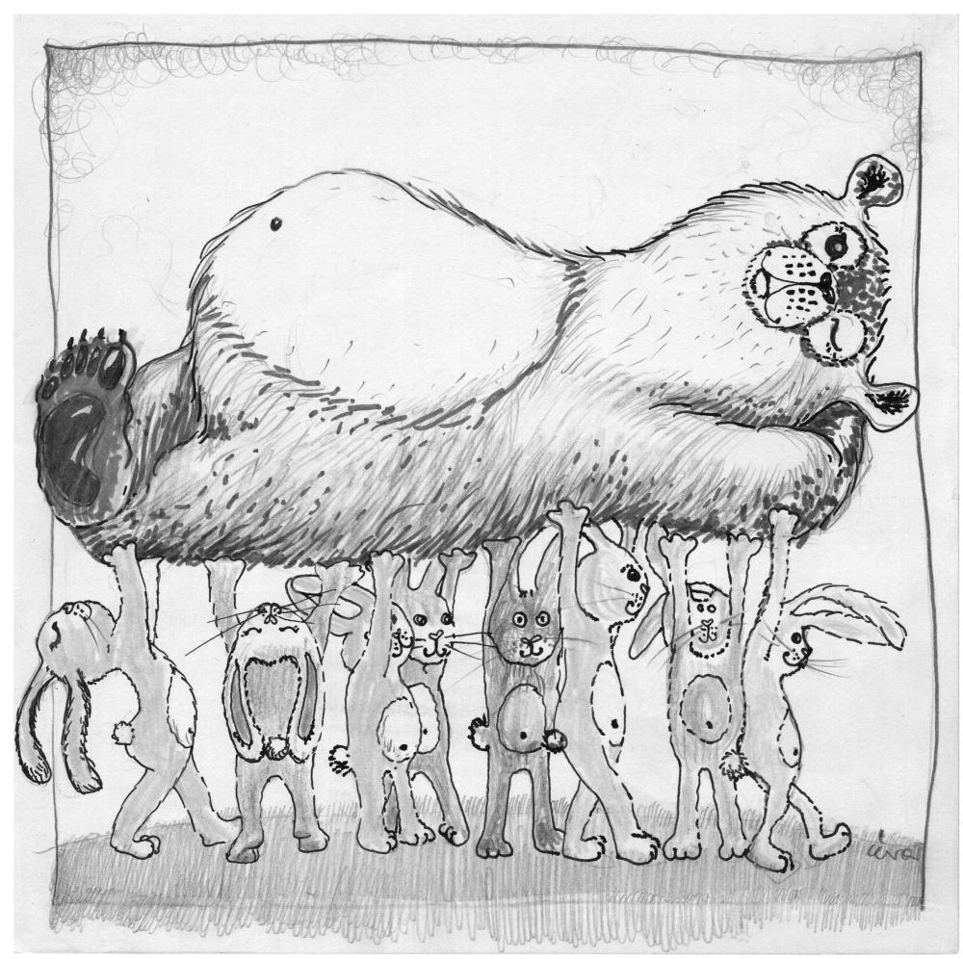

Daug rankų didžią naštą pakelia.

INDIVIDUAL TALK

You have just read a proverb. Your task is:
- to explain / interpret the meaning of the proverb;
- to give your opinion on the idea(s) expressed in the proverb (agree / disagree);
- to share your own experience / ideas related to the topic.

Preparation time 2-3 minutes. You can make notes if you wish in the space below.

You will have 1-2 minutes to give your talk.

https://ievaipieva.wordpress.com/2012/01/01/patarles/

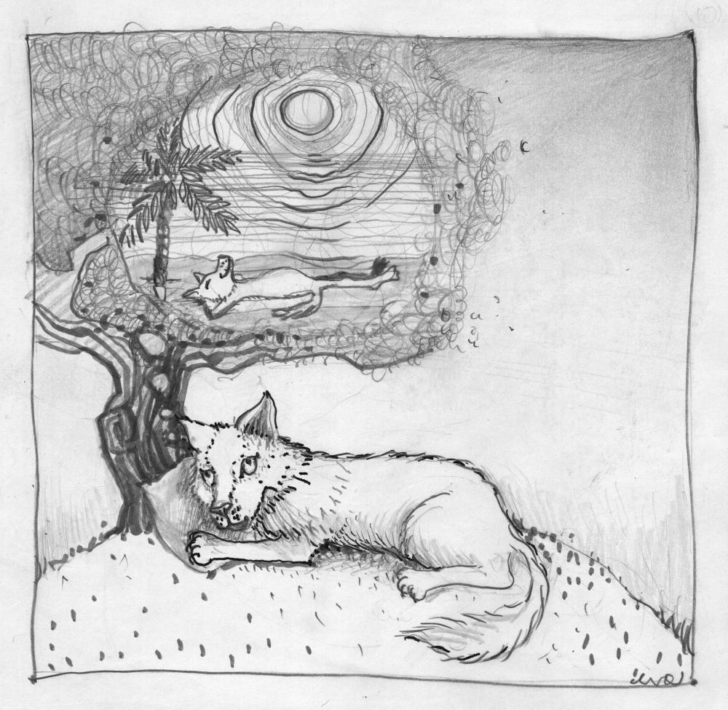

Ten gera, kur mūsų nėra.

INDIVIDUAL TALK

You have just read a proverb. Your task is:
- to explain / interpret the meaning of the proverb;
- to give your opinion on the idea(s) expressed in the proverb (agree / disagree);
- to share your own experience / ideas related to the topic.

Preparation time 2-3 minutes. You can make notes if you wish in the space below.

You will have 1-2 minutes to give your talk.

https://ievaipieva.wordpress.com/2012/01/01/patarles/

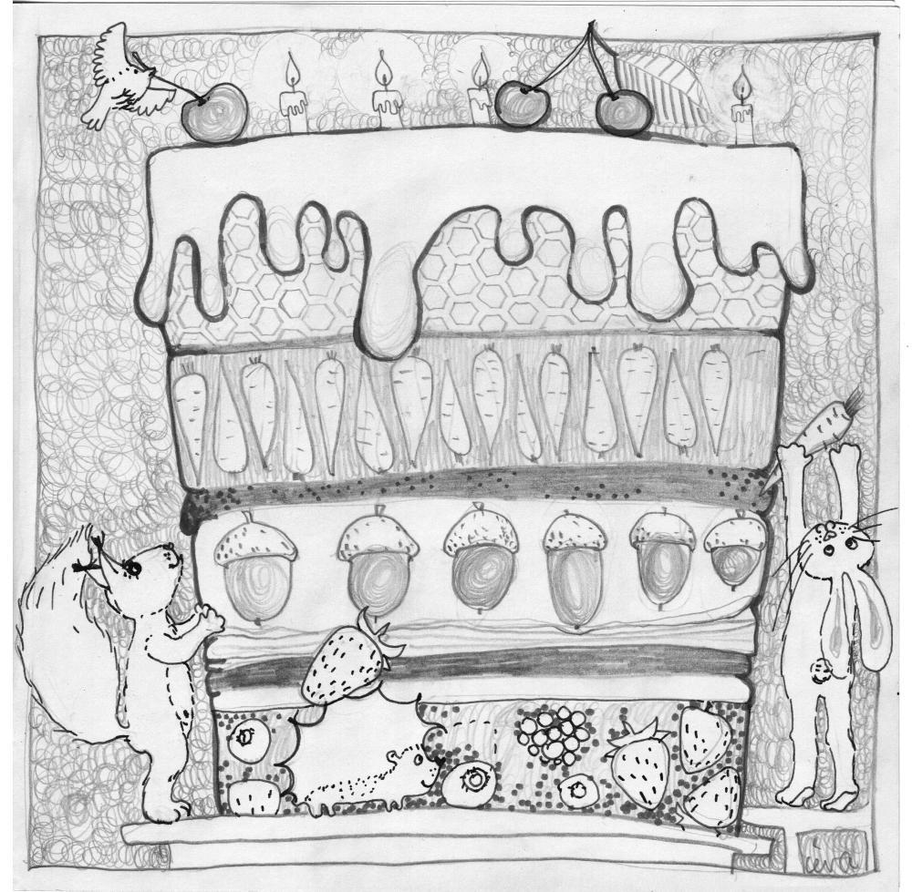

Geras darbas pats save giria.

INDIVIDUAL TALK

You have just read a proverb. Your task is:
- to explain / interpret the meaning of the proverb;
- to give your opinion on the idea(s) expressed in the proverb (agree / disagree);
- to share your own experience / ideas related to the topic.

Preparation time 2-3 minutes. You can make notes if you wish in the space below.

You will have 1-2 minutes to give your talk.

https://ievaipieva.wordpress.com/2012/01/01/patarles/

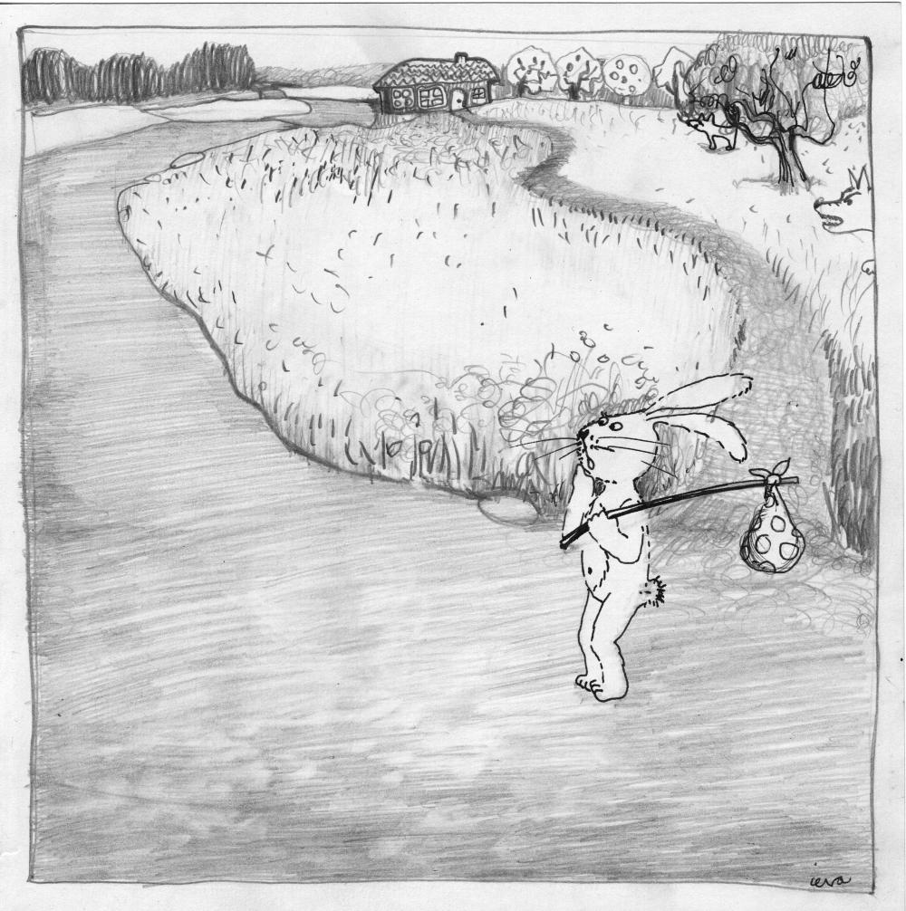

Nemesk kelio dėl takelio.

INDIVIDUAL TALK

You have just read a proverb. Your task is:
- to explain / interpret the meaning of the proverb;
- to give your opinion on the idea(s) expressed in the proverb (agree / disagree);
- to share your own experience / ideas related to the topic.

Preparation time 2-3 minutes. You can make notes if you wish in the space below.

You will have 1-2 minutes to give your talk.

http://markewbie.weebly.com/proverbs.html

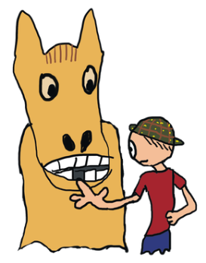

Dovanotam arkliui į dantis nežiūrima.

INDIVIDUAL TALK

You have just read a proverb. Your task is:
- to explain / interpret the meaning of the proverb;
- to give your opinion on the idea(s) expressed in the proverb (agree / disagree);
- to share your own experience / ideas related to the topic.

Preparation time 2-3 minutes. You can make notes if you wish in the space below.

You will have 1-2 minutes to give your talk.

http://markewbie.weebly.com/proverbs.html

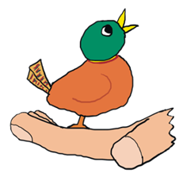

Geriau žvirblis rankoje negu briedis girioje.

INDIVIDUAL TALK

You have just read a proverb. Your task is:
- to explain / interpret the meaning of the proverb;
- to give your opinion on the idea(s) expressed in the proverb (agree / disagree);
- to share your own experience / ideas related to the topic.

Preparation time 2-3 minutes. You can make notes if you wish in the space below.

You will have 1-2 minutes to give your talk.

http://www.fluentu.com/english/blog/useful-english-proverbs/

Nespręsk apie knygą iš viršelio.

INDIVIDUAL TALK

You have just read a proverb. Your task is:
- to explain / interpret the meaning of the proverb;
- to give your opinion on the idea(s) expressed in the proverb (agree / disagree);
- to share your own experience / ideas related to the topic.

Preparation time 2-3 minutes. You can make notes if you wish in the space below.

You will have 1-2 minutes to give your talk.

http://www.fluentu.com/english/blog/useful-english-proverbs/

Neperšokęs griovio, nesakyk „op“.

INDIVIDUAL TALK

You have just read a proverb. Your task is:
- to explain / interpret the meaning of the proverb;
- to give your opinion on the idea(s) expressed in the proverb (agree / disagree);
- to share your own experience / ideas related to the topic.

Preparation time 2-3 minutes. You can make notes if you wish in the space below.

You will have 1-2 minutes to give your talk.

http://www.fluentu.com/english/blog/useful-english-proverbs/

Geriau vėliau negu niekada.

INDIVIDUAL TALK

You have just read a proverb. Your task is:
- to explain / interpret the meaning of the proverb;
- to give your opinion on the idea(s) expressed in the proverb (agree / disagree);
- to share your own experience / ideas related to the topic.

Preparation time 2-3 minutes. You can make notes if you wish in the space below.

You will have 1-2 minutes to give your talk.

http://www.fluentu.com/english/blog/useful-english-proverbs/

Kaip pasiklosi, taip išsimiegosi.

Student A

PAIR DISCUSSION

You are going to read a news item. You have to respond to the news and discuss it with a partner.

Your partner has also read the same news item.

You have 2 minutes to read the text and prepare for the discussion.

The discussion should take up to 3 minutes.

You are expected to:
- define the message / state the issue presented in the text (Student A);
- exchange opinions with the partner about the issue;
- justify your opinion, provide arguments;
- relate the issue to your own experience or knowledge, give examples;
- summarise and conclude your discussion (Student B).

Note: if you start the discussion, your partner will have to complete the discussion and vice versa.

Student A and Student B read the same news item.

Student A starts the conversation by summarising the news item.

Student B completes the conversation by summarising the discussion.

NO 1.
http://www.independent.co.uk/news/uk/home-news/
Gold treasure hoard discovered inside antique piano in Shropshire
A substantial amount of gold - described as “potential treasure” - has been found hidden in a piano.
The discovery of the stunning cache of gold items was made by the new owners of the piano when they decided to tune the instrument, which they had been given. They reported their discovery, and the items are now being kept safe in an unknown location.
Peter Reavill, of the British Museum, said: “We can't say what it is exactly because we are trying to track down the true owners. The current owners did not know what to do, but they came to the museum and they laid it all out on the table. I have never seen anything like that. It's a stunning assemblage of material.”
He said that the objects were highly unusual, made mostly of gold and appear to have been deliberately hidden within the last 110 years.
Experts are searching for the family of whoever put the treasure into the piano. If they are traced, they have a claim. If not, the items belong to the state.
Investigations have revealed that the piano, made by Broadwood & Sons of London, was sold to a music shop in Essex. The recent history of the piano has been traced to 1983 where it was purchased by a local family in Essex.
An inquest has now been opened to determine whether the hoard discovered in the piano qualifies as treasure under the Treasure Act (1996). For a hoard less than 300-years-old to be treasure, it must be substantially made of gold or silver, deliberately concealed by the owner with a view to later recovery and the owner must be unknown.

Student B

PAIR DISCUSSION

You are going to read a news item. You have to respond to the news and discuss it with a partner.

Your partner has also read the same news item.

You have 2 minutes to read the text and prepare for the discussion.

The discussion should take up to 3 minutes.

You are expected to:
- define the message / state the issue presented in the text (Student A);
- exchange opinions with the partner about the issue;
- justify your opinion, provide arguments;
- relate the issue to your own experience or knowledge, give examples;
- summarise and conclude your discussion (Student B).

Note: if you start the discussion, your partner will have to complete the discussion and vice versa.

Student A and Student B read the same news item.

Student A starts the conversation by summarising the news item.

Student B completes the conversation by summarising the discussion.

NO 1.
http://www.independent.co.uk/news/uk/home-news/
Gold treasure hoard discovered inside antique piano in Shropshire
A substantial amount of gold - described as “potential treasure” - has been found hidden in a piano.
The discovery of the stunning cache of gold items was made by the new owners of the piano when they decided to tune the instrument, which they had been given. They reported their discovery, and the items are now being kept safe in an unknown location.
Peter Reavill, of the British Museum, said: “We can't say what it is exactly because we are trying to track down the true owners. The current owners did not know what to do, but they came to the museum and they laid it all out on the table. I have never seen anything like that. It's a stunning assemblage of material.”
He said that the objects were highly unusual, made mostly of gold and appear to have been deliberately hidden within the last 110 years.
Experts are searching for the family of whoever put the treasure into the piano. If they are traced, they have a claim. If not, the items belong to the state.
Investigations have revealed that the piano, made by Broadwood & Sons of London, was sold to a music shop in Essex. The recent history of the piano has been traced to 1983 where it was purchased by a local family in Essex.
An inquest has now been opened to determine whether the hoard discovered in the piano qualifies as treasure under the Treasure Act (1996). For a hoard less than 300-years-old to be treasure, it must be substantially made of gold or silver, deliberately concealed by the owner with a view to later recovery and the owner must be unknown.

Student A

PAIR DISCUSSION

You are going to read a news item. You have to respond to the news and discuss it with a partner.

Your partner has also read the same news item.

You have 2 minutes to read the text and prepare for the discussion.

The discussion should take up to 3 minutes.

You are expected to:
- define the message / state the issue presented in the text (Student A);
- exchange opinions with the partner about the issue;
- justify your opinion, provide arguments;
- relate the issue to your own experience or knowledge, give examples;
- summarise and conclude your discussion (Student B).

Note: if you start the discussion, your partner will have to complete the discussion and vice versa.

Student A and Student B read the same news item.

Student A starts the conversation by summarising the news item.

Student B completes the conversation by summarising the discussion.

NO 2.
http://www.independent.co.uk/news/world/americas/

Teenager raises money for college after parents cut her off over black boyfriend
Allie Dowdle, a teenager from Tennessee, has launched a fund-raising campaign after her parents cut off her college fund when she started dating a black student.
“About a year ago, I told my parents that I'd started dating a boy named Michael. Hoping to share him with my family, I showed my parents his picture, and the conversation was over before it even began. My dad told me that I was not allowed to see Michael ever again. Why? Strictly because of skin colour. I couldn't comprehend how someone could be seen as a lesser person because of pigment.”
Allie said that she and Michael continued to see each other, discreetly. Then, she approached her parents again, thinking they may have had a change of heart. She said, they had not.
“As I am 18, my parents have chosen to no longer support my future, stripping me of all my resources including my personal savings, my car, my phone, and my education and leaving me on my own to pay for college.”
Allie’s father said that he and his wife would accept whomever their daughter wanted to date, but that he disapproved of Michael because Allie began dating him in secret. He said that he decided to cut off her college money because “it became obvious that she needed to go out in the world and grow up”.
Allie Dowdle has started the GoFundMe campaign with a plan to raise $10,000 for her college studies. So far, she has raised almost $13,000.

Student B

PAIR DISCUSSION

You are going to read a news item. You have to respond to the news and discuss it with a partner.

Your partner has also read the same news item.

You have 2 minutes to read the text and prepare for the discussion.

The discussion should take up to 3 minutes.

You are expected to:
- define the message / state the issue presented in the text (Student A);
- exchange opinions with the partner about the issue;
- justify your opinion, provide arguments;
- relate the issue to your own experience or knowledge, give examples;
- summarise and conclude your discussion (Student B).

Note: if you start the discussion, your partner will have to complete the discussion and vice versa.

Student A and Student B read the same news item.

Student A starts the conversation by summarising the news item.

Student B completes the conversation by summarising the discussion.

NO 2.
http://www.independent.co.uk/news/world/americas/

Teenager raises money for college after parents cut her off over black boyfriend'
Allie Dowdle, a teenager from Tennessee, has launched a fund-raising campaign after her parents cut off her college fund when she started dating a black student.
“About a year ago, I told my parents that I'd started dating a boy named Michael. Hoping to share him with my family, I showed my parents his picture, and the conversation was over before it even began. My dad told me that I was not allowed to see Michael ever again. Why? Strictly because of skin colour. I couldn't comprehend how someone could be seen as a lesser person because of pigment.”
Allie said that she and Michael continued to see each other, discreetly. Then, she approached her parents again, thinking they may have had a change of heart. She said, they had not.
“As I am 18, my parents have chosen to no longer support my future, stripping me of all my resources including my personal savings, my car, my phone, and my education and leaving me on my own to pay for college.”
Allie’s father said that he and his wife would accept whomever their daughter wanted to date, but that he disapproved of Michael because Allie began dating him in secret. He said that he decided to cut off her college money because “it became obvious that she needed to go out in the world and grow up”.
Allie Dowdle has started the GoFundMe campaign with a plan to raise $10,000 for her college studies. So far, she has raised almost $13,000.

Student A

PAIR DISCUSSION

You are going to read a news item. You have to respond to the news and discuss it with a partner.

Your partner has also read the same news item.

You have 2 minutes to read the text and prepare for the discussion.

The discussion should take up to 3 minutes.

You are expected to:
- define the message / state the issue presented in the text (Student A);
- exchange opinions with the partner about the issue;
- justify your opinion, provide arguments;
- relate the issue to your own experience or knowledge, give examples;
- summarise and conclude your discussion (Student B).

Note: if you start the discussion, your partner will have to complete the discussion and vice versa.

Student A and Student B read the same news item.

Student A starts the conversation by summarising the news item.

Student B completes the conversation by summarising the discussion.

NO 3.
http://www.msn.com/en-gb/travel/news/
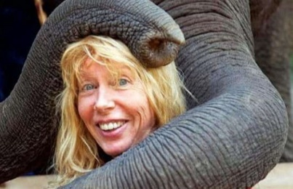

Why I’m backpacking around the world at 72
Geraldine Forster embarked on a global adventure following her retirement. Seven years on, she has visited 50 countries and is still travelling the world with her backpack.
When I retired, I bought a one-way ticket to Bangkok, packed a rucksack and waved goodbye to my family. I just knew I wanted to travel. So far I’ve visited 50 countries, from the completely unspoilt Myanmar to the magical Czech Republic. I’ve hugged elephants in Thailand, and eaten local delicacies in Cambodia. And I can’t imagine settling down.
I speak to my family regularly on Facebook, and I keep a blog so they know what I’m up to and where I am. I stay in hostels and often write about the people I meet.
My most dangerous trip so far was a tour of Kashmir, South Asia. The mountain landscape is dramatic, but it’s not the safest place and the Foreign Office advises against travelling around the region because of terrorism. I was also harassed a few times by men – it’s a very conservative Muslim area and, as a blonde woman on my own, I stood out. I’m only 5ft 1in, but I think of myself as pretty strong. If a man threatens me, I tell him to leave me alone, and I’m prepared to whack him with my camera if he doesn’t.
My family long for me to be a normal grandmother to my four grandchildren. I love them dearly but it’s not going to happen. We all have the right to realise our dreams and I still have 101 places to visit on my wish list. I hope my grandson, now 14, will join me on my travels when he’s old enough, but for now I’m happy to plod along alone.

Student B

PAIR DISCUSSION

You are going to read a news item. You have to respond to the news and discuss it with a partner.

Your partner has also read the same news item.

You have 2 minutes to read the text and prepare for the discussion.

The discussion should take up to 3 minutes.

You are expected to:
- define the message / state the issue presented in the text (Student A);
- exchange opinions with the partner about the issue;
- justify your opinion, provide arguments;
- relate the issue to your own experience or knowledge, give examples;
- summarise and conclude your discussion (Student B).

Note: if you start the discussion, your partner will have to complete the discussion and vice versa.

Student A and Student B read the same news item.

Student A starts the conversation by summarising the news item.

Student B completes the conversation by summarising the discussion.

NO 3.
http://www.msn.com/en-gb/travel/news/

Why I’m backpacking around the world at 72
Geraldine Forster embarked on a global adventure following her retirement. Seven years on, she has visited 50 countries and is still travelling the world with her backpack.
When I retired, I bought a one-way ticket to Bangkok, packed a rucksack and waved goodbye to my family. I just knew I wanted to travel. So far I’ve visited 50 countries, from the completely unspoilt Myanmar to the magical Czech Republic. I’ve hugged elephants in Thailand, and eaten local delicacies in Cambodia. And I can’t imagine settling down.
I speak to my family regularly on Facebook, and I keep a blog so they know what I’m up to and where I am. I stay in hostels and often write about the people I meet.
My most dangerous trip so far was a tour of Kashmir, South Asia. The mountain landscape is dramatic, but it’s not the safest place and the Foreign Office advises against travelling around the region because of terrorism. I was also harassed a few times by men – it’s a very conservative Muslim area and, as a blonde woman on my own, I stood out. I’m only 5ft 1in, but I think of myself as pretty strong. If a man threatens me, I tell him to leave me alone, and I’m prepared to whack him with my camera if he doesn’t.
My family long for me to be a normal grandmother to my four grandchildren. I love them dearly but it’s not going to happen. We all have the right to realise our dreams and I still have 101 places to visit on my wish list. I hope my grandson, now 14, will join me on my travels when he’s old enough, but for now I’m happy to plod along alone.

Student A

PAIR DISCUSSION

You are going to read a news item. You have to respond to the news and discuss it with a partner.

Your partner has also read the same news item.

You have 2 minutes to read the text and prepare for the discussion.

The discussion should take up to 3 minutes.

You are expected to:
- define the message / state the issue presented in the text (Student A);
- exchange opinions with the partner about the issue;
- justify your opinion, provide arguments;
- relate the issue to your own experience or knowledge, give examples;
- summarise and conclude your discussion (Student B).

Note: if you start the discussion, your partner will have to complete the discussion and vice versa.

Student A and Student B read the same news item.

Student A starts the conversation by summarising the news item.

Student B completes the conversation by summarising the discussion.

NO 4.
http://www.msn.com/en-gb/news/uknews/

Selfies can now be used in passport photos in UK, but Labour fear it could be a huge security risk
The Home Office has been criticised for allowing selfies to be used for passport photos. Labour party members say it makes forgery and fraud easier.
Lord Toby Harris said: “The passport is the gold standard as far as identity assurance is concerned. Digital photographs are much easier to manipulate and the possibility of fraud arises.”
But Home Office minister Baroness Williams defended the new system. She said: “A selfie that does not meet security standards is rejected in the examination process.”
The UK joined the US and New Zealand in allowing people to take their own photos for new digitalised passport application forms. The online service is only available to those aged 26 and over renewing their passports.
Selfies have made the headlines this week after security experts warned a popular photo app was collating data from users and sending it back to China. App Meitu, which creates Anime-style images from your snaps, records your location and phone number, as well as your phone's IMEI number.
One researcher claimed that this data could be sold on to third-party companies for targeted advertising.
However, Meitu's makers have insisted this is not the case."Our purpose for collecting the data is to optimise app performance and to understand our consumer needs. Meitu DOES NOT sell user data in any form."

Student B

PAIR DISCUSSION

You are going to read a news item. You have to respond to the news and discuss it with a partner.

Your partner has also read the same news item.

You have 2 minutes to read the text and prepare for the discussion.

The discussion should take up to 3 minutes.

You are expected to:
- define the message / state the issue presented in the text (Student A);
- exchange opinions with the partner about the issue;
- justify your opinion, provide arguments;
- relate the issue to your own experience or knowledge, give examples;
- summarise and conclude your discussion (Student B).

Note: if you start the discussion, your partner will have to complete the discussion and vice versa.

Student A and Student B read the same news item.

Student A starts the conversation by summarising the news item.

Student B completes the conversation by summarising the discussion.

NO 4.
http://www.msn.com/en-gb/news/uknews/

Selfies can now be used in passport photos in UK, but Labour fear it could be a huge security risk
The Home Office has been criticised for allowing selfies to be used for passport photos. Labour party members say it makes forgery and fraud easier.
Lord Toby Harris said: “The passport is the gold standard as far as identity assurance is concerned. Digital photographs are much easier to manipulate and the possibility of fraud arises.”
But Home Office minister Baroness Williams defended the new system. She said: “A selfie that does not meet security standards is rejected in the examination process.”
The UK joined the US and New Zealand in allowing people to take their own photos for new digitalised passport application forms. The online service is only available to those aged 26 and over renewing their passports.
Selfies have made the headlines this week after security experts warned a popular photo app was collating data from users and sending it back to China. App Meitu, which creates Anime-style images from your snaps, records your location and phone number, as well as your phone's IMEI number.
One researcher claimed that this data could be sold on to third-party companies for targeted advertising.
However, Meitu's makers have insisted this is not the case."Our purpose for collecting the data is to optimise app performance and to understand our consumer needs. Meitu DOES NOT sell user data in any form."

Student A

PAIR DISCUSSION

You are going to read a news item. You have to respond to the news and discuss it with a partner.

Your partner has also read the same news item.

You have 2 minutes to read the text and prepare for the discussion.

The discussion should take up to 3 minutes.

You are expected to:
- define the message / state the issue presented in the text (Student A);
- exchange opinions with the partner about the issue;
- justify your opinion, provide arguments;
- relate the issue to your own experience or knowledge, give examples;
- summarise and conclude your discussion (Student B).

Note: if you start the discussion, your partner will have to complete the discussion and vice versa.

Student A and Student B read the same news item.

Student A starts the conversation by summarising the news item.

Student B completes the conversation by summarising the discussion.

NO 5.
http://www.telegraph.co.uk/science/

257 minutes: the time teens can spend on computers each day before harming wellbeing
The rise in technology has led to fears that teenagers are damaging their social skills and mental health by spending increasing amounts of time online.
Yet when researchers quizzed 120,000 15-year-olds about their wellbeing and compared it to screen time, they found the use of gadgets had a positive impact. Researchers say that digital connectivity may enhance creativity, communication skills and intellectual development.
“Previous research has oversimplified the relationship between screen time and the mental abilities of teenagers,” said Dr Andrew Przybylski of the Universaity of Oxford. “We found that modern use of digital technology is not intrinsically harmful and may have advantages, unless digital devices are overused or interfere with schoolwork or after school activities.”
However the study did not take into account whether physical health was affected by spending too much time staring at screens. In 2014, researchers found that too much internet use caused brain shrinkage, and that using computers, smartphones or tablets before bedtime might disrupt sleep.
Sir Anthony Seldon of the University of Buckingham said: “Intelligent use of computers can enhance the life of teenagers but overall they are spending vastly too much time online. Real people, real exercise, real environments and real relationships are what young people need to develop into healthy adults. I’m extremely worried by the extensive exposure of adolescents to computers. It should be a very significant concern.”

Student B

PAIR DISCUSSION

You are going to read a news item. You have to respond to the news and discuss it with a partner.

Your partner has also read the same news item.

You have 2 minutes to read the text and prepare for the discussion.

The discussion should take up to 3 minutes.

You are expected to:
- define the message / state the issue presented in the text (Student A);
- exchange opinions with the partner about the issue;
- justify your opinion, provide arguments;
- relate the issue to your own experience or knowledge, give examples;
- summarise and conclude your discussion (Student B).

Note: if you start the discussion, your partner will have to complete the discussion and vice versa.

Student A and Student B read the same news item.

Student A starts the conversation by summarising the news item.

Student B completes the conversation by summarising the discussion.

NO 5.
http://www.telegraph.co.uk/science/

257 minutes: the time teens can spend on computers each day before harming wellbeing
The rise in technology has led to fears that teenagers are damaging their social skills and mental health by spending increasing amounts of time online.
Yet when researchers quizzed 120,000 15-year-olds about their wellbeing and compared it to screen time, they found the use of gadgets had a positive impact. Researchers say that digital connectivity may enhance creativity, communication skills and intellectual development.
“Previous research has oversimplified the relationship between screen time and the mental abilities of teenagers,” said Dr Andrew Przybylski of the Universaity of Oxford. “We found that modern use of digital technology is not intrinsically harmful and may have advantages, unless digital devices are overused or interfere with schoolwork or after school activities.”
However the study did not take into account whether physical health was affected by spending too much time staring at screens. In 2014, researchers found that too much internet use caused brain shrinkage, and that using computers, smartphones or tablets before bedtime might disrupt sleep.
Sir Anthony Seldon of the University of Buckingham said: “Intelligent use of computers can enhance the life of teenagers but overall they are spending vastly too much time online. Real people, real exercise, real environments and real relationships are what young people need to develop into healthy adults. I’m extremely worried by the extensive exposure of adolescents to computers. It should be a very significant concern.”

