YOUR NAME

WRITING TASK: ARTICLE

You are going to write an article for an English website.

Before writing, you are going to watch a short video presentation.The video will be shown twice.

You can take notes if you wish. Use this sheet for your notes.

After viewing the video presentation, you will have 60 minutes to write your article.

Follow this plan:
- state the topic / issue of the talk;
- give a very short summary of the content of the talk and formulate the main message;
- respond to the message of the talk by giving your opinion on the issue(s) discussed by the speaker and / or by linking the topic / issue to your personal experience;
- comment on the speaker’s presentation style (manner of speaking, visuals etc.).

Use the sheets provided for your draft and your final version.

Write at least 250 words.

Give a title to your article.

https://www.ted.com/talks/emilie_wapnick_why_some_of_us_don_t_have_one_true_calling

YOUR NOTES

YOUR DRAFT

YOUR NAME

YOUR FINAL VERSION

TITLE:

INDIVIDUAL TALK – 1

You have just read a proverb. Your task is:
- to explain / interpret the meaning of the proverb;
- to give your opinion on the idea(s) expressed in the proverb (agree / disagree);
- to share your own experience / ideas related to the topic.

Preparation time 2-3 minutes. You can make notes if you wish in the space below.

You will have 1-2 minutes to give your talk.

Pinigai ant medžių nekaba.

INDIVIDUAL TALK - 2

You have just read a proverb. Your task is:
- to explain / interpret the meaning of the proverb;
- to give your opinion on the idea(s) expressed in the proverb (agree / disagree);
- to share your own experience / ideas related to the topic.

Preparation time 2-3 minutes. You can make notes if you wish in the space below.

You will have 1-2 minutes to give your talk.

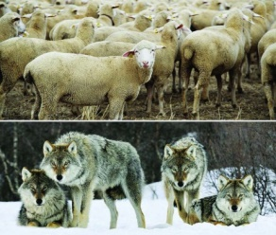

Ir vilkas sotus, ir avis sveika.

INDIVIDUAL TALK – 3

You have just read a proverb. Your task is:
- to explain / interpret the meaning of the proverb;
- to give your opinion on the idea(s) expressed in the proverb (agree / disagree);
- to share your own experience / ideas related to the topic.

Preparation time 2-3 minutes. You can make notes if you wish in the space below.

You will have 1-2 minutes to give your talk.

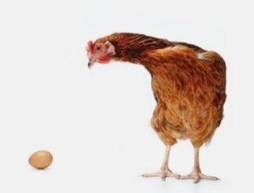

Kiaušinis vištą moko.

INDIVIDUAL TALK – 4

You have just read a proverb. Your task is:
- to explain / interpret the meaning of the proverb;
- to give your opinion on the idea(s) expressed in the proverb (agree / disagree);
- to share your own experience / ideas related to the topic.

Preparation time 2-3 minutes. You can make notes if you wish in the space below.

You will have 1-2 minutes to give your talk.

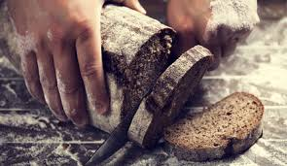

Kas skaito ir rašo, tas duonos neprašo.

INDIVIDUAL TALK – 5

You have just read a proverb. Your task is:
- to explain / interpret the meaning of the proverb;
- to give your opinion on the idea(s) expressed in the proverb (agree / disagree);
- to share your own experience / ideas related to the topic.

Preparation time 2-3 minutes. You can make notes if you wish in the space below.

You will have 1-2 minutes to give your talk.

Rytas už vakarą protingesnis.

INDIVIDUAL TALK – 6

You have just read a proverb. Your task is:
- to explain / interpret the meaning of the proverb;
- to give your opinion on the idea(s) expressed in the proverb (agree / disagree);
- to share your own experience / ideas related to the topic.

Preparation time 2-3 minutes. You can make notes if you wish in the space below.

You will have 1-2 minutes to give your talk.

Negirk dienos be vakaro.

INDIVIDUAL TALK – 7

You have just read a proverb. Your task is:
- to explain / interpret the meaning of the proverb;
- to give your opinion on the idea(s) expressed in the proverb (agree / disagree);
- to share your own experience / ideas related to the topic.

Preparation time 2-3 minutes. You can make notes if you wish in the space below.

You will have 1-2 minutes to give your talk.

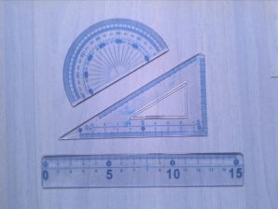

Devynis kartus pamatuok, o dešimtą – kirpk.

INDIVIDUAL TALK – 8

You have just read a proverb. Your task is:
- to explain / interpret the meaning of the proverb;
- to give your opinion on the idea(s) expressed in the proverb (agree / disagree);
- to share your own experience / ideas related to the topic.

Preparation time 2-3 minutes. You can make notes if you wish in the space below.

You will have 1-2 minutes to give your talk.

Visur gerai, o namie geriausia.

INDIVIDUAL TALK – 9

You have just read a proverb. Your task is:
- to explain / interpret the meaning of the proverb;
- to give your opinion on the idea(s) expressed in the proverb (agree / disagree);
- to share your own experience / ideas related to the topic.

Preparation time 2-3 minutes. You can make notes if you wish in the space below.

You will have 1-2 minutes to give your talk.

Moki žodį – rasi kelią.

INDIVIDUAL TALK – 10

You have just read a proverb. Your task is:
- to explain / interpret the meaning of the proverb;
- to give your opinion on the idea(s) expressed in the proverb (agree / disagree);
- to share your own experience / ideas related to the topic.

Preparation time 2-3 minutes. You can make notes if you wish in the space below.

You will have 1-2 minutes to give your talk.

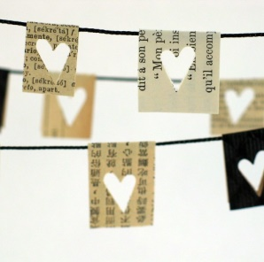

Ne piniguose laimė.

INDIVIDUAL TALK – 11

You have just read a proverb. Your task is:
- to explain / interpret the meaning of the proverb;
- to give your opinion on the idea(s) expressed in the proverb (agree / disagree);
- to share your own experience / ideas related to the topic.

Preparation time 2-3 minutes. You can make notes if you wish in the space below.

You will have 1-2 minutes to give your talk.

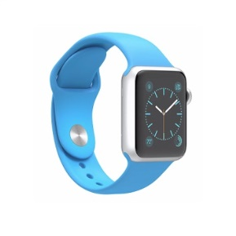

Geriau valandą palaukti, negu minutę pavėluoti.

INDIVIDUAL TALK – 12

You have just read a proverb. Your task is:
- to explain / interpret the meaning of the proverb;
- to give your opinion on the idea(s) expressed in the proverb (agree / disagree);
- to share your own experience / ideas related to the topic.

Preparation time 2-3 minutes. You can make notes if you wish in the space below.

You will have 1-2 minutes to give your talk.

Melo kojos trumpos.

INDIVIDUAL TALK – 13

You have just read a proverb. Your task is:
- to explain / interpret the meaning of the proverb;
- to give your opinion on the idea(s) expressed in the proverb (agree / disagree);
- to share your own experience / ideas related to the topic.

Preparation time 2-3 minutes. You can make notes if you wish in the space below.

You will have 1-2 minutes to give your talk.

Draugą nelaimėje pažinsi.

INDIVIDUAL TALK – 14

You have just read a proverb. Your task is:
- to explain / interpret the meaning of the proverb;
- to give your opinion on the idea(s) expressed in the proverb (agree / disagree);
- to share your own experience / ideas related to the topic.

Preparation time 2-3 minutes. You can make notes if you wish in the space below.

You will have 1-2 minutes to give your talk.

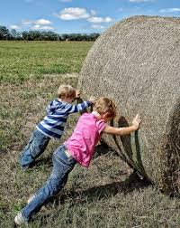

Kur du stos, visada daugiau padarys.

INDIVIDUAL TALK – 15

You have just read a proverb. Your task is:
- to explain / interpret the meaning of the proverb;
- to give your opinion on the idea(s) expressed in the proverb (agree / disagree);
- to share your own experience / ideas related to the topic.

Preparation time 2-3 minutes. You can make notes if you wish in the space below.

You will have 1-2 minutes to give your talk.

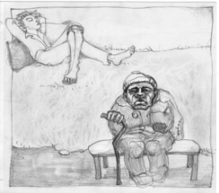

Jaunas tinginiausi, senas ubagausi.

INDIVIDUAL TALK – 16

You have just read a proverb. Your task is:
- to explain / interpret the meaning of the proverb;
- to give your opinion on the idea(s) expressed in the proverb (agree / disagree);
- to share your own experience / ideas related to the topic.

Preparation time 2-3 minutes. You can make notes if you wish in the space below.

You will have 1-2 minutes to give your talk.

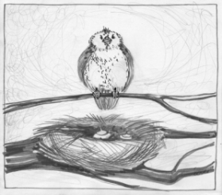

Blogas paukštis, kuris savo lizdą teršia.

Student A

TASK THREE: PAIR DISCUSSION

You are going to read a news item. You have to respond to the news and discuss it with a partner.

Your partner has also read the same news item.

You have 2 minutes to read the text and prepare for the discussion.

The discussion should take up to 3 minutes.

You are expected to:
- identify the topic / state the issue / formulate the idea of the text (Student A);
- exchange opinions with the partner about the issue;
- justify your opinion, provide arguments;
- relate the issue to your own experience or knowledge, give examples;
- summarise and conclude your discussion (Student B).

Note: if you start the discussion, your partner will have to complete the discussion and vice versa.

NO 1.

http://www.msn.com/en-gb/news/offbeat/selfie-taker-smashes-pumpkin-sculpture/ar-AAnQc8d

Selfie-taker smashes pumpkin sculpture
The art of the selfie can be destructive to art. Just last year, a man climbed a 126-year-old statue in Lisbon, Portugal, to take a selfie and brought it crumbling down. Recently, art work at the Smithsonian Museum and Sculpture Garden in the US capital suffered a similar fate.

As Artnet reports, a man was wandering through a museum room called "All the Eternal Love I Have for the Pumpkins”, which is the creation of Japanese artist Yayoi Kusama. It seems that the man was moved to take a selfie. However, he was so overcome by the art that he slipped. He fell on one of the pumpkin sculptures and damaged it.

A spokeswoman for the museum told me that the incident was "unintentional" and the room was opened again the next day. She added that the pumpkin, one of 60 in the room, could be replaced. However, she said that in response to this selfie-taker's imbalance, the museum had added extra security to protect against any recurrence.

“There's no point pleading to selfie-takers to stop. It's so much a part of contemporary culture that it's the way many people define their lives to themselves and describe them to others”, the spokeswoman said.

Student B

TASK THREE: PAIR DISCUSSION

You are going to read a news item. You have to respond to the news and discuss it with a partner.

Your partner has also read the same news item.

You have 2 minutes to read the text and prepare for the discussion.

The discussion should take up to 3 minutes.

You are expected to:
- identify the topic / state the issue / formulate the idea of the text (Student A);
- exchange opinions with the partner about the issue;
- justify your opinion, provide arguments;
- relate the issue to your own experience or knowledge, give examples;
- summarise and conclude your discussion (Student B).

Note: if you start the discussion, your partner will have to complete the discussion and vice versa.

NO 1.

http://www.msn.com/en-gb/news/offbeat/selfie-taker-smashes-pumpkin-sculpture/ar-AAnQc8d

Selfie-taker smashes pumpkin sculpture
The art of the selfie can be destructive to art. Just last year, a man climbed a 126-year-old statue in Lisbon, Portugal, to take a selfie and brought it crumbling down. Recently, art work at the Smithsonian Museum and Sculpture Garden in the US capital suffered a similar fate.

As Artnet reports, a man was wandering through a museum room called "All the Eternal Love I Have for the Pumpkins”, which is the creation of Japanese artist Yayoi Kusama. It seems that the man was moved to take a selfie. However, he was so overcome by the art that he slipped. He fell on one of the pumpkin sculptures and damaged it.

A spokeswoman for the museum told me that the incident was "unintentional" and the room was opened again the next day. She added that the pumpkin, one of 60 in the room, could be replaced. However, she said that in response to this selfie-taker's imbalance, the museum had added extra security to protect against any recurrence.

“There's no point pleading to selfie-takers to stop. It's so much a part of contemporary culture that it's the way many people define their lives to themselves and describe them to others”, the spokeswoman said.

Student A

TASK THREE: PAIR DISCUSSION

You are going to read a news item. You have to respond to the news and discuss it with a partner.

Your partner has also read the same news item.

You have 2 minutes to read the text and prepare for the discussion.

The discussion should take up to 3 minutes.

You are expected to:
- identify the topic / state the issue / formulate the idea of the text (Student A);
- exchange opinions with the partner about the issue;
- justify your opinion, provide arguments;
- relate the issue to your own experience or knowledge, give examples;
- summarise and conclude your discussion (Student B).

Note: if you start the discussion, your partner will have to complete the discussion and vice versa.

NO 2.

http://edition.cnn.com/2017/04/03/travel/britain-red-telephone-box-reinvented/

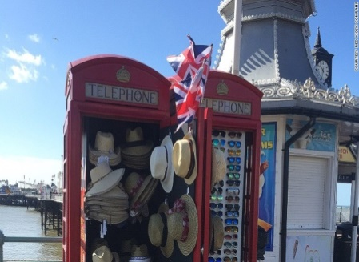 Britain's classic red telephone boxes get a makeover

The red British telephone booth is a universally recognized icon. It was first introduced in 1924. More than 90 years later, the phone box is a popular backdrop for thousands of selfies, but thanks to smartphones, they are becoming obsolete. Some, however, are being preserved as part of the national heritage.

British Telecom introduced an "adopt a kiosk" program, encouraging communities to buy phone boxes for £1 and give them a new life. "We want to save as many as we can”, BT said.

“In the seaside town of Brighton, two phone boxes were spotted by locals Edward and Steve: "We thought we could sell sunglasses and sunhats from them". They also helped their friend transform a phone box into a thriving cafe, which is regularly photographed, making numerous appearances on Instagram and Facebook.

In the Scottish hamlet of Merrywell, the community has converted its local phone box into an nternet cafe – a digital oasis in the Scottish Highlands where 3G and 4G phone signals are hard to find. Another community came together to transform a phone box into a mini-library.

Telephone boxes are also being converted into mini work stations for tourists. Its booths are decked out with printers, a 25-inch screen, a powerbank of plugs and a hot drinks machine.

Student B

TASK THREE: PAIR DISCUSSION

You are going to read a news item. You have to respond to the news and discuss it with a partner.

Your partner has also read the same news item.

You have 2 minutes to read the text and prepare for the discussion.

The discussion should take up to 3 minutes.

You are expected to:
- identify the topic / state the issue / formulate the idea of the text (Student A);
- exchange opinions with the partner about the issue;
- justify your opinion, provide arguments;
- relate the issue to your own experience or knowledge, give examples;
- summarise and conclude your discussion (Student B).

Note: if you start the discussion, your partner will have to complete the discussion and vice versa.

NO 2.

http://edition.cnn.com/2017/04/03/travel/britain-red-telephone-box-reinvented/

Britain's classic red telephone boxes get a makeover

The red British telephone booth is a universally recognized icon. It was first introduced in 1924. More than 90 years later, the phone box is a popular backdrop for thousands of selfies, but thanks to smartphones, they are becoming obsolete. Some, however, are being preserved as part of the national heritage.

British Telecom introduced an "adopt a kiosk" program, encouraging communities to buy phone boxes for £1 and give them a new life. "We want to save as many as we can”, BT said.

“In the seaside town of Brighton, two phone boxes were spotted by locals Edward and Steve: "We thought we could sell sunglasses and sunhats from them". They also helped their friend transform a phone box into a thriving cafe, which is regularly photographed, making numerous appearances on Instagram and Facebook.

In the Scottish hamlet of Merrywell, the community has converted its local phone box into an nternet cafe – a digital oasis in the Scottish Highlands where 3G and 4G phone signals are hard to find. Another community came together to transform a phone box into a mini-library.

Telephone boxes are also being converted into mini work stations for tourists. Its booths are decked out with printers, a 25-inch screen, a powerbank of plugs and a hot drinks machine.

Student A

TASK THREE: PAIR DISCUSSION

You are going to read a news item. You have to respond to the news and discuss it with a partner.

Your partner has also read the same news item.

You have 2 minutes to read the text and prepare for the discussion.

The discussion should take up to 3 minutes.

You are expected to:
- identify the topic / state the issue / formulate the idea of the text (Student A);
- exchange opinions with the partner about the issue;
- justify your opinion, provide arguments;
- relate the issue to your own experience or knowledge, give examples;
- summarise and conclude your discussion (Student B).

Note: if you start the discussion, your partner will have to complete the discussion and vice versa.

NO 3.

http://www.huffingtonpost.com/entry/senior-couple-breaks-world-record-for-most-tattos
Senior Couple Breaks World Record For Most Tattoos On The Body

They’ve both been recognized by Guinness World Records.

Charlotte Guttenberg, 67, says that when she got her first tattoo 10 years ago, her mother thought she had become “a child of the devil.” Today, with tattoos covering 91.5 percent of her body, she’s just been named as the most tattooed female senior citizen on the planet.

And the love of her life, Charles “Chuck” Helmke? At age 75, he’s also just been recognized as the most tattooed male senior citizen, with 93.75 percent of his body covered in ink.

Chuck got his first tattoo when he was in the U.S. Army, in 1959. After getting a few more tattoos with some army buddies, he went on a 40-year hiatus and did not get another tattoo until 2000. The retired self-defense trainer met Charlotte, an author, in late 2006 as she was getting a fairly substantial tattoo. He kindly sat beside her to help ease her nerves. The two, both from Melbourne, Florida, fell in love and have been together since 2007.

They both say they’re honored to have achieved the Guinness recognition. Charlotte hopes to use her newfound fame to promote mutual respect among tattooed and un-tattooed people.

Student B

TASK THREE: PAIR DISCUSSION

You are going to read a news item. You have to respond to the news and discuss it with a partner.

Your partner has also read the same news item.

You have 2 minutes to read the text and prepare for the discussion.

The discussion should take up to 3 minutes.

You are expected to:
- identify the topic / state the issue / formulate the idea of the text (Student A);
- exchange opinions with the partner about the issue;
- justify your opinion, provide arguments;
- relate the issue to your own experience or knowledge, give examples;
- summarise and conclude your discussion (Student B).

Note: if you start the discussion, your partner will have to complete the discussion and vice versa.

NO 3.

http://www.huffingtonpost.com/entry/senior-couple-breaks-world-record-for-most-tattoos
Senior Couple Breaks World Record For Most Tattoos On The Body

They’ve both been recognized by Guinness World Records.

Charlotte Guttenberg, 67, says that when she got her first tattoo 10 years ago, her mother thought she had become “a child of the devil.” Today, with tattoos covering 91.5 percent of her body, she’s just been named as the most tattooed female senior citizen on the planet.

And the love of her life, Charles “Chuck” Helmke? At age 75, he’s also just been recognized as the most tattooed male senior citizen, with 93.75 percent of his body covered in ink.

Chuck got his first tattoo when he was in the U.S. Army, in 1959. After getting a few more tattoos with some army buddies, he went on a 40-year hiatus and did not get another tattoo until 2000. The retired self-defense trainer met Charlotte, an author, in late 2006 as she was getting a fairly substantial tattoo. He kindly sat beside her to help ease her nerves. The two, both from Melbourne, Florida, fell in love and have been together since 2007.

They both say they’re honored to have achieved the Guinness recognition. Charlotte hopes to use her newfound fame to promote mutual respect among tattooed and un-tattooed people.

Student A

TASK THREE: PAIR DISCUSSION

You are going to read a news item. You have to respond to the news and discuss it with a partner.

Your partner has also read the same news item.

You have 2 minutes to read the text and prepare for the discussion.

The discussion should take up to 3 minutes.

You are expected to:
- identify the topic / state the issue / formulate the idea of the text (Student A);
- exchange opinions with the partner about the issue;
- justify your opinion, provide arguments;
- relate the issue to your own experience or knowledge, give examples;
- summarise and conclude your discussion (Student B).

Note: if you start the discussion, your partner will have to complete the discussion and vice versa.

NO 4.

http://www.msn.com/en-gb/news/offbeat/man-pays-for-elderly-womans-supermarket-shopping

Man pays for elderly woman's supermarket shopping after her card was declined

A supermarket shopper has been hailed an “absolute champion” after he paid for an elderly woman’s shopping when her card was declined. Ryan O’Donnell, a father of two, noticed the woman in front of him was having difficulty paying at the supermarket so stepped in to settle her bill. He said he intervened because “that’s how my mum and dad brought me up.”

“I was just there at checkout with my kids and I saw the old lady having some trouble with the card. She swiped it quite a number of times and then they took her around to the front counter and got her to keep trying. By that stage my groceries had gone through and I went around and spoke to the shop assistant and said ‘how much is it’ and she said $44 or something. The old lady’s card kept being declined so I said ‘Look, here’s $50 just take it out of that’.”

Mr O’Donnell said the lady had wished to pay him back and was concerned about how she was going to return the money. “I said ‘Oh look, don’t worry about it — it’s only $44, you’ll be right and enjoy your day’.”

Social media users have praised Ryan as a "legend", “good samaritan” and “awesome guy.” "There should be more people like him in this world. If we all knew how to help, think of how amazing life would be?" one user wrote on Twitter. Another wrote: "What a nice person! Humans at their best."

Student B

TASK THREE: PAIR DISCUSSION

You are going to read a news item. You have to respond to the news and discuss it with a partner.

Your partner has also read the same news item.

You have 2 minutes to read the text and prepare for the discussion.

The discussion should take up to 3 minutes.

You are expected to:
- identify the topic / state the issue / formulate the idea of the text (Student A);
- exchange opinions with the partner about the issue;
- justify your opinion, provide arguments;
- relate the issue to your own experience or knowledge, give examples;
- summarise and conclude your discussion (Student B).

Note: if you start the discussion, your partner will have to complete the discussion and vice versa.

NO 4.

http://www.msn.com/en-gb/news/offbeat/man-pays-for-elderly-womans-supermarket-shopping

Man pays for elderly woman's supermarket shopping after her card was declined

A supermarket shopper has been hailed an “absolute champion” after he paid for an elderly woman’s shopping when her card was declined. Ryan O’Donnell, a father of two, noticed the woman in front of him was having difficulty paying at the supermarket so stepped in to settle her bill. He said he intervened because “that’s how my mum and dad brought me up.”

“I was just there at checkout with my kids and I saw the old lady having some trouble with the card. She swiped it quite a number of times and then they took her around to the front counter and got her to keep trying. By that stage my groceries had gone through and I went around and spoke to the shop assistant and said ‘how much is it’ and she said $44 or something. The old lady’s card kept being declined so I said ‘Look, here’s $50 just take it out of that’.”

Mr O’Donnell said the lady had wished to pay him back and was concerned about how she was going to return the money. “I said ‘Oh look, don’t worry about it — it’s only $44, you’ll be right and enjoy your day’.”

Social media users have praised Ryan as a "legend", “good samaritan” and “awesome guy.” "There should be more people like him in this world. If we all knew how to help, think of how amazing life would be?" one user wrote on Twitter. Another wrote: "What a nice person! Humans at their best."

Student A

TASK THREE: PAIR DISCUSSION

You are going to read a news item. You have to respond to the news and discuss it with a partner.

Your partner has also read the same news item.

You have 2 minutes to read the text and prepare for the discussion.

The discussion should take up to 3 minutes.

You are expected to:
- identify the topic / state the issue / formulate the idea of the text (Student A);
- exchange opinions with the partner about the issue;
- justify your opinion, provide arguments;
- relate the issue to your own experience or knowledge, give examples;
- summarise and conclude your discussion (Student B).

Note: if you start the discussion, your partner will have to complete the discussion and vice versa.

NO 5.

http://www.msn.com/en-gb/news/offbeat/man-finds-million-dollar-lotto-ticket-a-year-on/
Man finds million-dollar lotto ticket after a year

An Australian grandfather has become an instant millionaire after finding his lost ticket while cleaning his car - a year after the winning numbers were drawn. The unidentified winner from New South Wales bought the ticket in January 2016 and found it at the bottom of a shopping bag.

"I was cleaning rubbish out of my car on the weekend and thought it was time to put new cartons in the bottom of all my bags as they were starting to get torn and I got quite a surprise," he said. "The ticket was hidden underneath it and I didn't know it was there.I'm glad I didn't just get the old bags and take them to the dump."

He checked the numbers online and found he had won just over one million Australian dollars (£620,000).

"There's a few people who are going to benefit from this. I want to help the kids with their house payments and the grandkids with their education. It will smooth the troubled water in front of them."

Cheryl Tuckerman, who owns the newsagent where the man bought the Lottery ticket, said: "You wouldn't believe how many customers we've had coming in during the past year asking whether the winner had been found. We're excited to be able to tell them that now it has."

Student B

TASK THREE: PAIR DISCUSSION

You are going to read a news item. You have to respond to the news and discuss it with a partner.

Your partner has also read the same news item.

You have 2 minutes to read the text and prepare for the discussion.

The discussion should take up to 3 minutes.

You are expected to:
- identify the topic / state the issue / formulate the idea of the text (Student A);
- exchange opinions with the partner about the issue;
- justify your opinion, provide arguments;
- relate the issue to your own experience or knowledge, give examples;
- summarise and conclude your discussion (Student B).

Note: if you start the discussion, your partner will have to complete the discussion and vice versa.

NO 5.

http://www.msn.com/en-gb/news/offbeat/man-finds-million-dollar-lotto-ticket-a-year-on/
Man finds million-dollar lotto ticket after a year

An Australian grandfather has become an instant millionaire after finding his lost ticket while cleaning his car - a year after the winning numbers were drawn. The unidentified winner from New South Wales bought the ticket in January 2016 and found it at the bottom of a shopping bag.

"I was cleaning rubbish out of my car on the weekend and thought it was time to put new cartons in the bottom of all my bags as they were starting to get torn and I got quite a surprise," he said. "The ticket was hidden underneath it and I didn't know it was there.I'm glad I didn't just get the old bags and take them to the dump."

He checked the numbers online and found he had won just over one million Australian dollars (£620,000).

"There's a few people who are going to benefit from this. I want to help the kids with their house payments and the grandkids with their education. It will smooth the troubled water in front of them."

Cheryl Tuckerman, who owns the newsagent where the man bought the Lottery ticket, said: "You wouldn't believe how many customers we've had coming in during the past year asking whether the winner had been found. We're excited to be able to tell them that now it has."

Student A

TASK THREE: PAIR DISCUSSION

You are going to read a news item. You have to respond to the news and discuss it with a partner.

Your partner has also read the same news item.

You have 2 minutes to read the text and prepare for the discussion.

The discussion should take up to 3 minutes.

You are expected to:
- identify the topic / state the issue / formulate the idea of the text (Student A);
- exchange opinions with the partner about the issue;
- justify your opinion, provide arguments;
- relate the issue to your own experience or knowledge, give examples;
- summarise and conclude your discussion (Student B).

Note: if you start the discussion, your partner will have to complete the discussion and vice versa.

NO 6.

http://www.msn.com/en-gb/news/offbeat/wallet-lost-in-1952-returned-to-owners-son/ar-AAnHyff

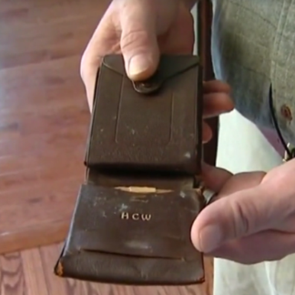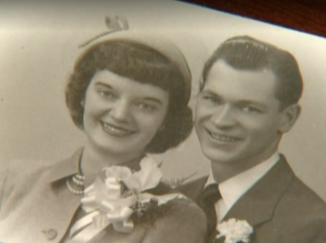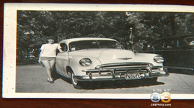

Wallet lost in 1952 returned to owner's son
A wallet has been returned to the son of its owner after being sealed behind a bathroom wall 65 years ago. It was discovered by a contractor working on a home in Pennsylvania, where it was sealed behind a medicine cabinet. The contractor managed to track down Adam Weber, whose late father Harry Weber had done tile work on the home in 1952.
“The last Weber to hold it was 65 years ago,” Adam told us. There was no money in the wallet, but other mementos were found inside, including a photo that Adam hadn’t seen in years. “The one thing that really hit me was the wedding picture, because I hadn’t seen it in 12 years,” Adam said, holding back tears.
His father’s bank card, a weekly pay stub and a photo of his prized car, an Oldsmobile Rocket 88, were also discovered in the wallet. “I thought he was kidding me about his car, Rocket 88. I never believed he had owned a Rocket 88”.
Adam’s father died in 2005. His initials appear on the inside of the wallet. “It’s a nice way to reconnect with him again,” Adam said. He is now considering leaving a wallet of his own hidden in his walls for his children to find.

Student B

TASK THREE: PAIR DISCUSSION

You are going to read a news item. You have to respond to the news and discuss it with a partner.

Your partner has also read the same news item.

You have 2 minutes to read the text and prepare for the discussion.

The discussion should take up to 3 minutes.

You are expected to:
- identify the topic / state the issue / formulate the idea of the text (Student A);
- exchange opinions with the partner about the issue;
- justify your opinion, provide arguments;
- relate the issue to your own experience or knowledge, give examples;
- summarise and conclude your discussion (Student B).

Note: if you start the discussion, your partner will have to complete the discussion and vice versa.

NO 6.

http://www.msn.com/en-gb/news/offbeat/wallet-lost-in-1952-returned-to-owners-son/ar-AAnHyff

Wallet lost in 1952 returned to owner's son
A wallet has been returned to the son of its owner after being sealed behind a bathroom wall 65 years ago. It was discovered by a contractor working on a home in Pennsylvania, where it was sealed behind a medicine cabinet. The contractor managed to track down Adam Weber, whose late father Harry Weber had done tile work on the home in 1952.
“The last Weber to hold it was 65 years ago,” Adam told us. There was no money in the wallet, but other mementos were found inside, including a photo that Adam hadn’t seen in years. “The one thing that really hit me was the wedding picture, because I hadn’t seen it in 12 years,” Adam said, holding back tears.
His father’s bank card, a weekly pay stub and a photo of his prized car, an Oldsmobile Rocket 88, were also discovered in the wallet. “I thought he was kidding me about his car, Rocket 88. I never believed he had owned a Rocket 88”.
Adam’s father died in 2005. His initials appear on the inside of the wallet. “It’s a nice way to reconnect with him again,” Adam said. He is now considering leaving a wallet of his own hidden in his walls for his children to find.

Student A

TASK THREE: PAIR DISCUSSION

You are going to read a news item. You have to respond to the news and discuss it with a partner.

Your partner has also read the same news item.

You have 2 minutes to read the text and prepare for the discussion.

The discussion should take up to 3 minutes.

You are expected to:
- identify the topic / state the issue / formulate the idea of the text (Student A);
- exchange opinions with the partner about the issue;
- justify your opinion, provide arguments;
- relate the issue to your own experience or knowledge, give examples;
- summarise and conclude your discussion (Student B).

Note: if you start the discussion, your partner will have to complete the discussion and vice versa.

NO 7.

http://www.msn.com/en-gb/news/offbeat/6-year-old-boy-receives-outstanding-citizens-award
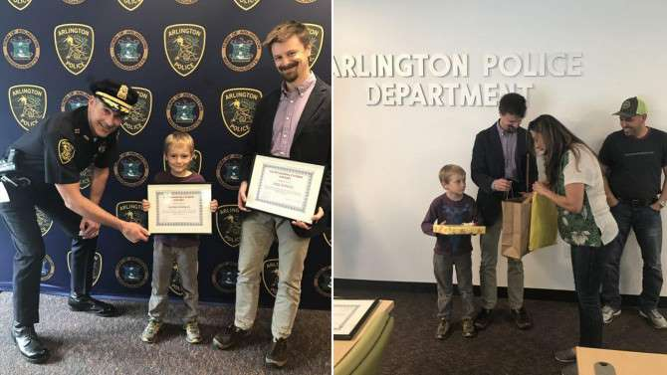

6-Year-Old Boy Receives Outstanding Citizen's Award After Returning $2,000 He Found

Massachusetts police recognized a 6-year-old boy and his father after they turned in $2,000 in cash that they found to police. Arlington Police awarded first-grader Jasper Dopman an Outstanding Citizen’s Award after he turned in the bank bag that belonged to a family-owned restaurant in the city.

Police said Jasper was walking with his father, Erik Dopman, when he spotted the bag on the ground and pointed it out to his dad. Inside the bag was $2,000 and deposit slips from a local bank. Dopman called the Police Department and turned the bag in. "This situation shows the very definition of good citizenship. Jasper and his dad Erik demonstrated what it means to be part of a community by returning missing money to its rightful owner,” said Police Chief.

Bank officials led the police to Guadalupe Alvarez, an employee at Mexican Food Restaurant, who confirmed that she had lost the bag earlier. Father and son Dopman visited the Police Department and were introduced to the restaurant owner.

"Erik imparted an extremely valuable lesson on his son," Chief Ryan said. "It is hard to imagine the panic and fear that sets in when someone loses a large amount of money for their employer. Jasper and Erik did the right thing, and I commend their actions."

Student B

TASK THREE: PAIR DISCUSSION

You are going to read a news item. You have to respond to the news and discuss it with a partner.

Your partner has also read the same news item.

You have 2 minutes to read the text and prepare for the discussion.

The discussion should take up to 3 minutes.

You are expected to:
- identify the topic / state the issue / formulate the idea of the text (Student A);
- exchange opinions with the partner about the issue;
- justify your opinion, provide arguments;
- relate the issue to your own experience or knowledge, give examples;
- summarise and conclude your discussion (Student B).

Note: if you start the discussion, your partner will have to complete the discussion and vice versa.

NO 7.

http://www.msn.com/en-gb/news/offbeat/6-year-old-boy-receives-outstanding-citizens-award

6-Year-Old Boy Receives Outstanding Citizen's Award After Returning $2,000 He Found

Massachusetts police recognized a 6-year-old boy and his father after they turned in $2,000 in cash that they found to police. Arlington Police awarded first-grader Jasper Dopman an Outstanding Citizen’s Award after he turned in the bank bag that belonged to a family-owned restaurant in the city.

Police said Jasper was walking with his father, Erik Dopman, when he spotted the bag on the ground and pointed it out to his dad. Inside the bag was $2,000 and deposit slips from a local bank. Dopman called the Police Department and turned the bag in. "This situation shows the very definition of good citizenship. Jasper and his dad Erik demonstrated what it means to be part of a community by returning missing money to its rightful owner,” said Police Chief.

Bank officials led the police to Guadalupe Alvarez, an employee at Mexican Food Restaurant, who confirmed that she had lost the bag earlier. Father and son Dopman visited the Police Department and were introduced to the restaurant owner.

"Erik imparted an extremely valuable lesson on his son," Chief Ryan said. "It is hard to imagine the panic and fear that sets in when someone loses a large amount of money for their employer. Jasper and Erik did the right thing, and I commend their actions."

Student A

TASK THREE: PAIR DISCUSSION

You are going to read a news item. You have to respond to the news and discuss it with a partner.

Your partner has also read the same news item.

You have 2 minutes to read the text and prepare for the discussion.

The discussion should take up to 3 minutes.

You are expected to:
- identify the topic / state the issue / formulate the idea of the text (Student A);
- exchange opinions with the partner about the issue;
- justify your opinion, provide arguments;
- relate the issue to your own experience or knowledge, give examples;
- summarise and conclude your discussion (Student B).

Note: if you start the discussion, your partner will have to complete the discussion and vice versa.

NO 8.

http://www.msn.com/en-gb/news/offbeat/6-year-old-sees-man-lying-in-parking-lot-saves-his-life/
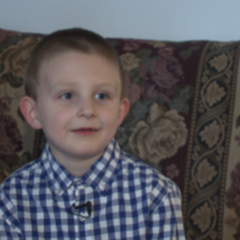 6-year-old sees man lying in parking lot, saves his life

Six-year-old Karter Thorpe was sitting in the back seat as his grandmother drove through a parking lot when he saw something unsettling: a man lying on the ground, seemingly lifeless. The man, who was sprawled across the pavement next to a truck, started to twitch — and that’s when Karter yelled at his grandma, Carolyn Cook, to turn around.

Carolyn Cook thought her grandson was just exaggerating. She kept on driving, but Karter wouldn’t let it go. “No, you have to stop! He’s hurt. You have to go back!” he screamed.

As Cook made a U-turn, she saw a pair of feet peeking out behind a truck. Sure enough, a man was lying on the ground. “He was gasping for air,” described Cook, who stopped her car in the middle of the aisle to run to his aid.

She pulled out her cellphone and dialed 911. Luckily, another passerby stopped and gave basic first aid until an ambulance arrived and transported the man to a nearby hospital.

Cook never got the man’s name, so she wasn’t sure what happened to him — until his family reached out to her on Facebook, one week after the incident. The man’s family told her he suffered a massive heart attack and he would have died if it weren’t for Karter’s quick response. The man’s family said Karter Thorpe is their “little angel.”

Student B

TASK THREE: PAIR DISCUSSION

You are going to read a news item. You have to respond to the news and discuss it with a partner.

Your partner has also read the same news item.

You have 2 minutes to read the text and prepare for the discussion.

The discussion should take up to 3 minutes.

You are expected to:
- identify the topic / state the issue / formulate the idea of the text (Student A);
- exchange opinions with the partner about the issue;
- justify your opinion, provide arguments;
- relate the issue to your own experience or knowledge, give examples;
- summarise and conclude your discussion (Student B).

Note: if you start the discussion, your partner will have to complete the discussion and vice versa.

NO 8.

http://www.msn.com/en-gb/news/offbeat/6-year-old-sees-man-lying-in-parking-lot-saves-his-life/
6-year-old sees man lying in parking lot, saves his life

Six-year-old Karter Thorpe was sitting in the back seat as his grandmother drove through a parking lot when he saw something unsettling: a man lying on the ground, seemingly lifeless. The man, who was sprawled across the pavement next to a truck, started to twitch — and that’s when Karter yelled at his grandma, Carolyn Cook, to turn around.

Carolyn Cook thought her grandson was just exaggerating. She kept on driving, but Karter wouldn’t let it go. “No, you have to stop! He’s hurt. You have to go back!” he screamed.

As Cook made a U-turn, she saw a pair of feet peeking out behind a truck. Sure enough, a man was lying on the ground. “He was gasping for air,” described Cook, who stopped her car in the middle of the aisle to run to his aid.

She pulled out her cellphone and dialed 911. Luckily, another passerby stopped and gave basic first aid until an ambulance arrived and transported the man to a nearby hospital.

Cook never got the man’s name, so she wasn’t sure what happened to him — until his family reached out to her on Facebook, one week after the incident. The man’s family told her he suffered a massive heart attack and he would have died if it weren’t for Karter’s quick response. The man’s family said Karter Thorpe is their “little angel.”

Student A

TASK THREE: PAIR DISCUSSION

You are going to read a news item. You have to respond to the news and discuss it with a partner.

Your partner has also read the same news item.

You have 2 minutes to read the text and prepare for the discussion.

The discussion should take up to 3 minutes.

You are expected to:
- identify the topic / state the issue / formulate the idea of the text (Student A);
- exchange opinions with the partner about the issue;
- justify your opinion, provide arguments;
- relate the issue to your own experience or knowledge, give examples;
- summarise and conclude your discussion (Student B).

Note: if you start the discussion, your partner will have to complete the discussion and vice versa.

NO 9.

http://www.msn.com/en-gb/news/offbeat/man-returns-stolen-library-book-35-years-later

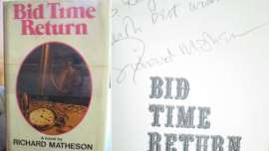

Man Returns Stolen Library Book 35 Years Later - With Author's Autograph

A man who says he stole a book from a library 35 years ago has more than made up for it — by returning the restored book with the author's autograph inside. He also sent a $200 donation to the Public Library in Montana when he returned Richard Matheson’s Bid Time Return by mail.

The library's director received a package containing the book, the check and a one-page apology letter. "It was very surprising to me, because the library never knew the book was missing. At the time it was stolen in 1982, our catalog wasn't computerized and we didn't know it was gone”, she said.

But it apparently went to a good home. In his letter, the man explained that he'd read the book at least 25 times and he'd had it restored over the years. He even met the author at one point and got him to sign it.

"This is not my book," he wrote in the letter. "It belongs in the Public Library — wrongfully taken, yes, but if you can, kindly take into consideration it has been loved and cared for all these years and please know I am sorry for taking it."

The director was just happy to receive the package. "I thanked him for writing to us. He truly did love this book," she said. "The love of reading... that's the takeaway."

Student B

TASK THREE: PAIR DISCUSSION

You are going to read a news item. You have to respond to the news and discuss it with a partner.

Your partner has also read the same news item.

You have 2 minutes to read the text and prepare for the discussion.

The discussion should take up to 3 minutes.

You are expected to:
- identify the topic / state the issue / formulate the idea of the text (Student A);
- exchange opinions with the partner about the issue;
- justify your opinion, provide arguments;
- relate the issue to your own experience or knowledge, give examples;
- summarise and conclude your discussion (Student B).

Note: if you start the discussion, your partner will have to complete the discussion and vice versa.

NO 9.

http://www.msn.com/en-gb/news/offbeat/man-returns-stolen-library-book-35-years-later

Man Returns Stolen Library Book 35 Years Later - With Author's Autograph

A man who says he stole a book from a library 35 years ago has more than made up for it — by returning the restored book with the author's autograph inside. He also sent a $200 donation to the Public Library in Montana when he returned Richard Matheson’s Bid Time Return by mail.

The library's director received a package containing the book, the check and a one-page apology letter. "It was very surprising to me, because the library never knew the book was missing. At the time it was stolen in 1982, our catalog wasn't computerized and we didn't know it was gone”, she said.

But it apparently went to a good home. In his letter, the man explained that he'd read the book at least 25 times and he'd had it restored over the years. He even met the author at one point and got him to sign it.

"This is not my book," he wrote in the letter. "It belongs in the Public Library — wrongfully taken, yes, but if you can, kindly take into consideration it has been loved and cared for all these years and please know I am sorry for taking it."

The director was just happy to receive the package. "I thanked him for writing to us. He truly did love this book," she said. "The love of reading... that's the takeaway."

Student A

TASK THREE: PAIR DISCUSSION

You are going to read a news item. You have to respond to the news and discuss it with a partner.

Your partner has also read the same news item.

You have 2 minutes to read the text and prepare for the discussion.

The discussion should take up to 3 minutes.

You are expected to:
- identify the topic / state the issue / formulate the idea of the text (Student A);
- exchange opinions with the partner about the issue;
- justify your opinion, provide arguments;
- relate the issue to your own experience or knowledge, give examples;
- summarise and conclude your discussion (Student B).

Note: if you start the discussion, your partner will have to complete the discussion and vice versa.

NO 10.

http://www.independent.co.uk/news/world/asia/india-electric-cars-2030

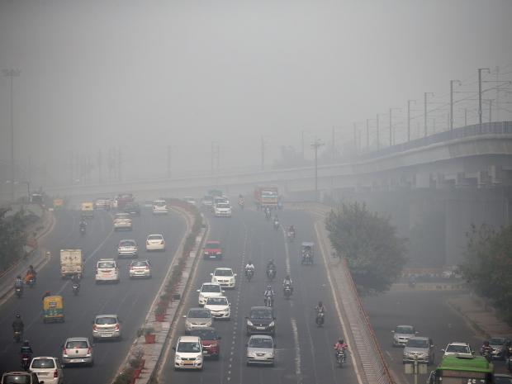
India to make every single car electric by 2030 in bid to tackle pollution

Every car sold in India will be powered by electricity by the year 2030, according to plans unveiled by the country’s energy minister.

The move is intended to lower the cost of importing fuel and lower costs for running vehicles.
“We are going to introduce electric vehicles in a very big way," coal and mines minister Piyush Goyal said at the Confederation of Indian Industry Annual Session 2017 in New Delhi.

Comparing the drive to a 2015 initiative in the country to reduce energy bills by promoting LED lightbulbs, he told reporters: "We are going to make electric vehicles self-sufficient... The idea is that by 2030, not a single petrol or diesel car should be sold in the country.”

Mr Goyal said the electric car industry would need between two and three years of government assistance, but added that he expected the production of the vehicles to be “driven by demand and not subsidy” after that.

"The cost of electric vehicles will start to pay for itself for consumers," he said according to the International Business Times. “We would love to see the electric vehicle industry run on its own," he added.

Student B

TASK THREE: PAIR DISCUSSION

You are going to read a news item. You have to respond to the news and discuss it with a partner.

Your partner has also read the same news item.

You have 2 minutes to read the text and prepare for the discussion.

The discussion should take up to 3 minutes.

You are expected to:
- identify the topic / state the issue / formulate the idea of the text (Student A);
- exchange opinions with the partner about the issue;
- justify your opinion, provide arguments;
- relate the issue to your own experience or knowledge, give examples;
- summarise and conclude your discussion (Student B).

Note: if you start the discussion, your partner will have to complete the discussion and vice versa.

NO 10.

http://www.independent.co.uk/news/world/asia/india-electric-cars-2030

India to make every single car electric by 2030 in bid to tackle pollution

Every car sold in India will be powered by electricity by the year 2030, according to plans unveiled by the country’s energy minister.

The move is intended to lower the cost of importing fuel and lower costs for running vehicles.
“We are going to introduce electric vehicles in a very big way," coal and mines minister Piyush Goyal said at the Confederation of Indian Industry Annual Session 2017 in New Delhi.

Comparing the drive to a 2015 initiative in the country to reduce energy bills by promoting LED lightbulbs, he told reporters: "We are going to make electric vehicles self-sufficient... The idea is that by 2030, not a single petrol or diesel car should be sold in the country.”

Mr Goyal said the electric car industry would need between two and three years of government assistance, but added that he expected the production of the vehicles to be “driven by demand and not subsidy” after that.

"The cost of electric vehicles will start to pay for itself for consumers," he said according to the International Business Times. “We would love to see the electric vehicle industry run on its own," he added.

ARTICLE ASSESSMENT SCALE (updated for 2017)
CRITERIA | score | DESCRIPTORS
Content | 3 | All content points covered. Thorough and extensive coverage.  Good balance of content points.
 | 2 | Major content points covered. Adequate coverage.  Minor problems with balance of content points.
 | 1 | Too few content points covered. Some irrelevant material.  Major problems with balance of content points.
Organisation and layout | 3 | Ideas effectively organized / linked. Proper layout.
 | 2 | Ideas adequately organized / linked. Minor probems with layout.
 | 1 | Lack of organization / linking. Major problems with layout.
Range of vocabulary and structure +  Register | 4 | Extremely wide range of structure and vocabulary. Appropriate use of register.
 | 3 | Good range of structure and vocabulary. Appropriate use of register.
 | 2 | Adequate range of structure and vocabulary. Minor proboms with register.
 | 1 | Limited / Narrow range of structure and vocabulary. Problems with register.
Accuracy  (vocabulary, grammar, spelling, punctuation) | 4 | No errors / minimal errors.
 | 3 | A few minor errors in complex structures.
 | 2 | A number of errors in complex structures; communication not obscured.
 | 1 | Frequent errors, some of which may obscure communication.
Bonus point | 1 | One point can be added for exceptional creativity and/or originality of ideas.
Total |  | ASSESSOR’S SIGNATURE AND COMMENT

NOTES
- Length – minimum 250 words. If the text is shorter, the score is adjusted as agreed by the committee.
- Spelling – British and American varieties are acceptable. Contractions are acceptable.
- A bonus point can be added for exceptional creativity and/or originality of ideas.
- If the score is 14 or 15 – please the inform the chief assessor.
- If the score is less than 10 – please inform the chief assessor.

INDIVIDUAL TALK based on a proverb / quote
ASSESSMENT SCALE (updated for 2017)
SCORE |  | DESCRIPTORS
Introduction / Interpretation of the statement (proverb / quote)
2 | Effective introduction / interpretation of the statement.
1 | Adequate introduction / interpretation of the statement.
Expressing opinion / coherent argumentation. Sharing experience / ideas / examples
3 | Excellent argumentation and coherence. Highly relevant ideas / examples.
2 | Good argumentation and coherence. Relevant ideas and examples.
1 | Adequate argumentation and coherence. Some irrelevance of ideas and examples may be noticed.
Language resources (lexico-grammatical structures)
3 | Wide range of language resources; always used clearly and precisely to convey the content.
2 | Good range of language resources; most often used clearly and precisely to convey the content.
1 | Adequate range of language resources; lack of clarity and precision may be noticed.
Fluency
3 | Smooth flow of language with natural hesitation / pauses. Easy to follow.
2 | Rather smooth flow of language with natural hesitation / pauses. Quite easy to follow.
1 | Uneven flow of language; frequent hesitation / pauses. May be difficult to follow.
Accuracy
3 | Excellent control of simple and complex lexico-grammatical structures; no or a few minor errors in complex structures. Meaning is never obscured.
2 | Good control of simple and complex lexico-grammatical structures; occassional errors in simple and complex structures. Meaning is never obscured.
1 | Adequate handling of simple lexico-grammatical structures; problems may occur with both simple and complex structures. Meaning may be obscured.
Pronunciation
1 | Clear articulation. Effective intonation.
0 | Adequate articulation and intonation.
Total  (out of 15) |  |  | Assessor’s signature and comment.

PAIR DISCUSSION
ASSESSMENT SCALE (updated for 2017)
CRITERIA |  |  | SCORE | DESCRIPTORS
CONTENT
*Introduction (Student A)
2 | Effective summary of the news item and initiation of the discussion.
1 | Adequate summary of the news item and initiation of the discussion.
Response to the issue / argumentation / examples
3 | Highly effective response to the issue / argumentation / use of examples.
2 | Good response to the issue / argumentation / use of examples.
1 | Adequate response to the issue / argumentation / use of examples.
Language resources
3 | Wide range of language structures; the meaning is always clear and precise.
2 | Adequate range of language structures; the meaning is generally clear and precise.
1 | Limited range of language structures; the meaning is not always clear or precise.
*Conclusion (Student B)
2 | Effective summary of the main points and excellent final comment.
1 | Adequate summary of the main points and acceptable final comment.
DELIVERY
Interaction
3 |  | Highly effective use of strategies maintain discussion and involve/respond to the partner.
2 |  | Good use of strategies maintain discussion and involve/respond to the partner.
1** |  | Adequate use of strategies to maintain discussion and involve/respond to the partner.
Accuracy
3 | Excellent control of simple and complex lexico-grammatical structures; no accuracy errors.
2 | Good control of simple and complex lexico-grammatical structures; occassional minor errors.
1 | Adequate handling of simple structures; problems may occur with complex structures.
Pronunciation
1 | Clear articulation. Effective intonation.
0 | Adequate articulation and intonation.
Total (out of 15)
* Student A gets points for the introduction and Student B - for the conclusion.
** 1 point may be subtracted from the overall score of the student who dominates the discussion.

