Participant’s NAME

(first name, surname)

ENGLISH LANGUAGE CONTEST 2015 (FORMS 9–10)

TASK THREE: PICTURE STORY

You have a set of pictures. The pictures make a story. However, the story is incomplete.Your task is
- to tell the story which is illustrated in the pictures and
- to complete the story in any way you wish.

Preparation time 2-3 minutes. You can make notes if you wish in the space below.

You will have 1-2 minutes to tell the whole story to the audience / teachers.

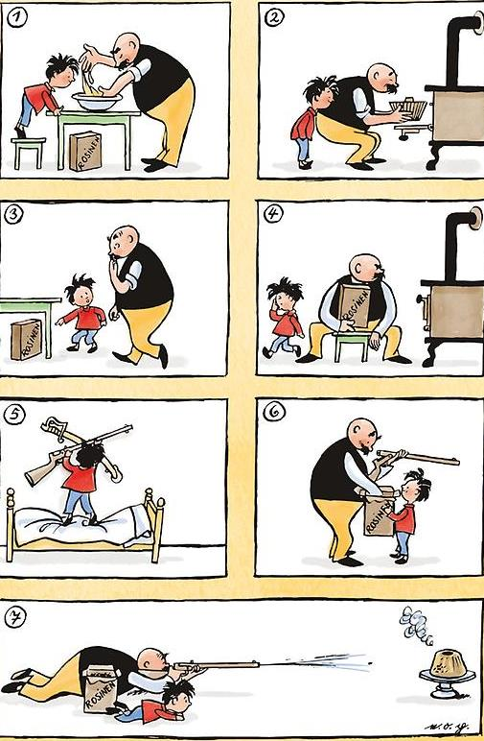
http://www.digitale-schule-bayern.de/

WHAT HAPPENED NEXT?

COMPLETE THE STORY IN ANY WAY YOU WISH.

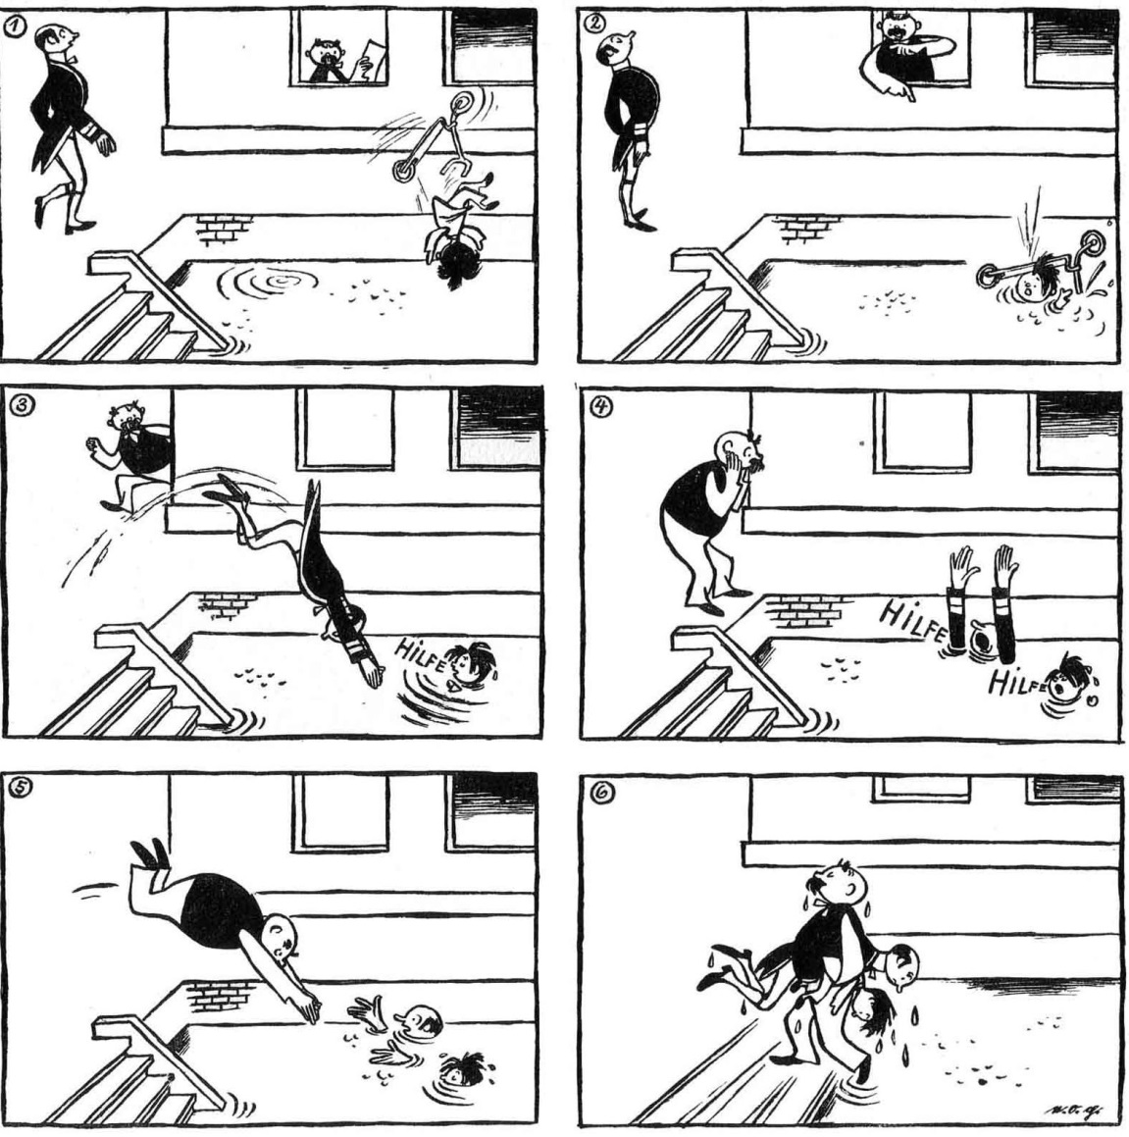
http://www.digitale-schule-bayern.de/

WHAT HAPPENED NEXT?

COMPLETE THE STORY IN ANY WAY YOU WISH.

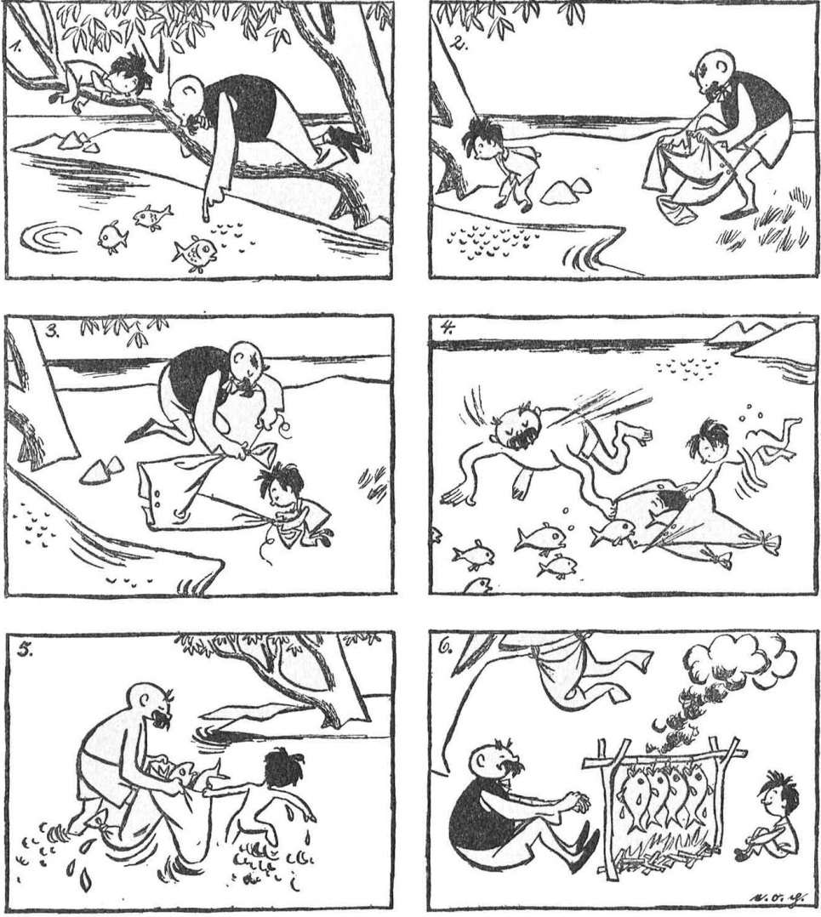
http://www.digitale-schule-bayern.de/

WHAT HAPPENED NEXT?

COMPLETE THE STORY IN ANY WAY YOU WISH.

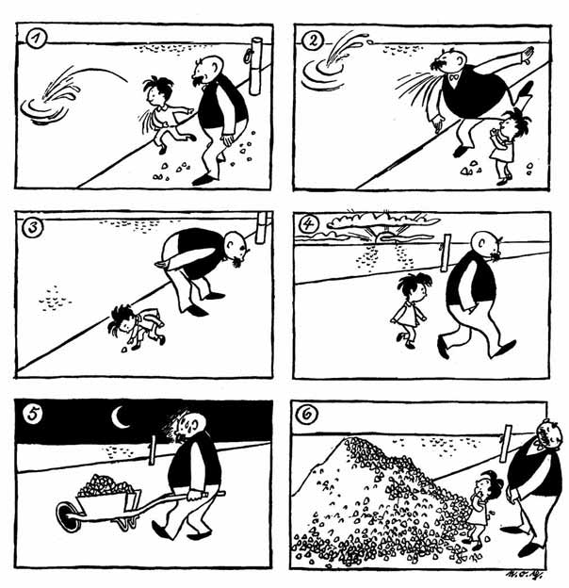
http://www.digitale-schule-bayern.de/

WHAT HAPPENED NEXT?

COMPLETE THE STORY IN ANY WAY YOU WISH.

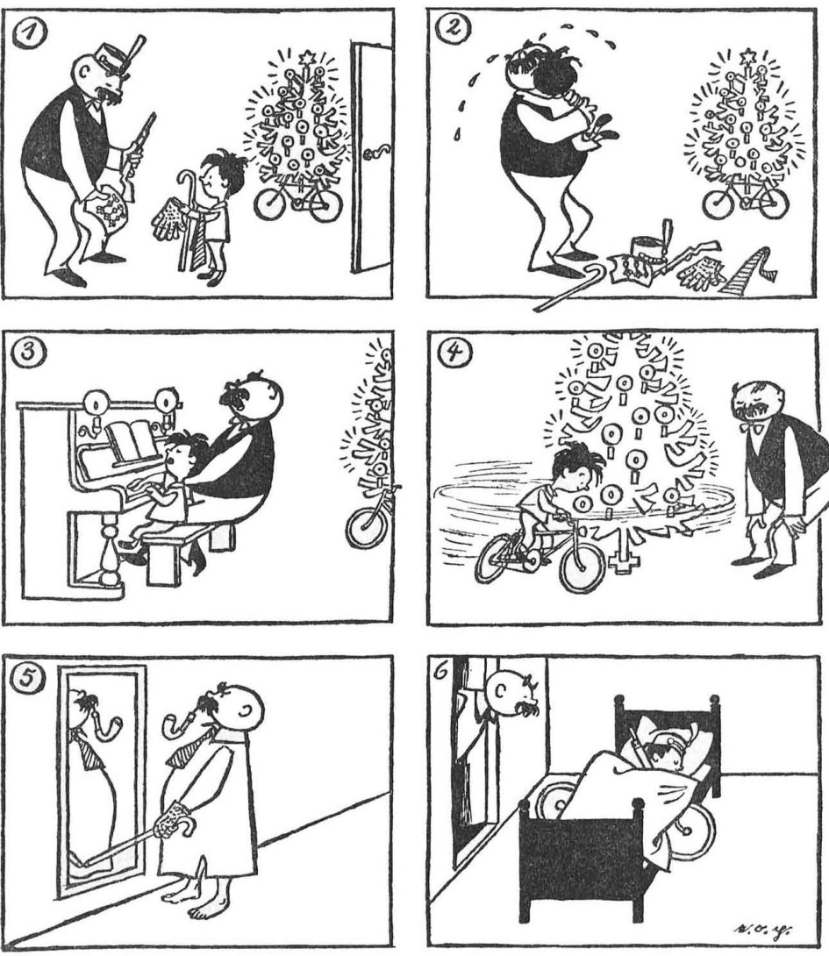
http://www.digitale-schule-bayern.de/

WHAT HAPPENED NEXT?

COMPLETE THE STORY IN ANY WAY YOU WISH.

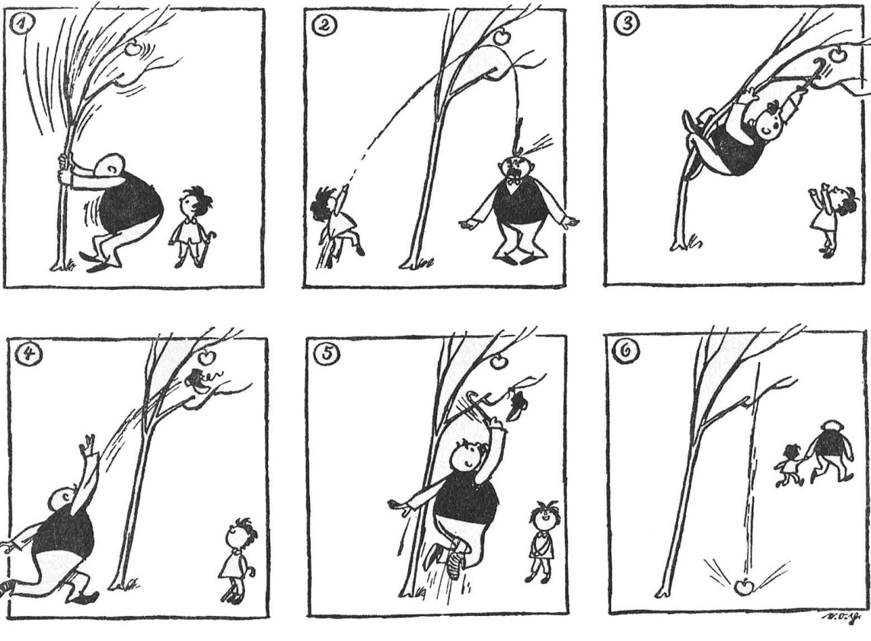
http://www.digitale-schule-bayern.de/

WHAT HAPPENED NEXT?

COMPLETE THE STORY IN ANY WAY YOU WISH.

ENGLISH LANGUAGE CONTEST 2015 (FORMS 9–10)

Student A

TASK FOUR: PAIR DISCUSSION

You will be given a picture. You have to respond to the issue represented in the picture and discuss it with a partner. Your partner has the same picture. You have 2 minutes to look at the picture and prepare for the discussion. You are expected to:
- identify the problem / state the issue represented in the picture (Student A);
- exchange opinions with the partner about the issue;
- justify your opinion, provide arguments;
- relate the issue to your own experience or knowledge, give examples;
- summarise and conclude your discussion (Student B).

Note: if you start the discussion, your partner will have to complete the discussion and vice versa.

NO 1.
http://laimikis.lt/uzlopyk-spalvotai-dispatch-the-walls/

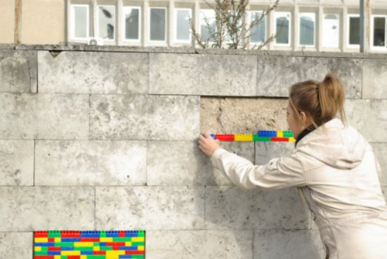

ENGLISH LANGUAGE CONTEST 2015 (FORMS 9–10)

Student B

TASK FOUR: PAIR DISCUSSION

You will be given a picture. You have to respond to the issue represented in the picture and discuss it with a partner. Your partner has the same picture. You have 2 minutes to look at the picture and prepare for the discussion. You are expected to:
- identify the problem / state the issue represented in the picture (Student A);
- exchange opinions with the partner about the issue;
- justify your opinion, provide arguments;
- relate the issue to your own experience or knowledge, give examples;
- summarise and conclude your discussion (Student B).

Note: if you start the discussion, your partner will have to complete the discussion and vice versa.

NO 1.
http://laimikis.lt/uzlopyk-spalvotai-dispatch-the-walls/

ENGLISH LANGUAGE CONTEST 2015 (FORMS 9–10)

Student A

TASK FOUR: PAIR DISCUSSION

You will be given a picture. You have to respond to the issue represented in the picture and discuss it with a partner. Your partner has the same picture. You have 2 minutes to look at the picture and prepare for the discussion. You are expected to:
- identify the problem / state the issue represented in the picture (Student A);
- exchange opinions with the partner about the issue;
- justify your opinion, provide arguments;
- relate the issue to your own experience or knowledge, give examples;
- summarise and conclude your discussion (Student B).

Note: if you start the discussion, your partner will have to complete the discussion and vice versa.

NO 2.
http://www.photosbrightonandhove.org.uk/cyclists-crossing-church-road.html

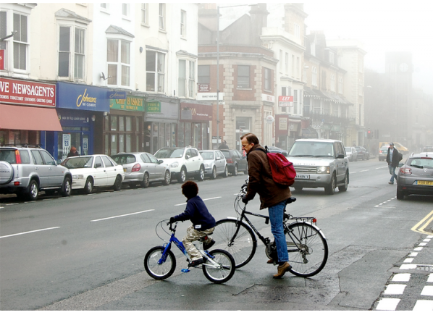

ENGLISH LANGUAGE CONTEST 2015 (FORMS 9–10)

Student B

TASK FOUR: PAIR DISCUSSION

You will be given a picture. You have to respond to the issue represented in the picture and discuss it with a partner. Your partner has the same picture. You have 2 minutes to look at the picture and prepare for the discussion. You are expected to:
- identify the problem / state the issue represented in the picture (Student A);
- exchange opinions with the partner about the issue;
- justify your opinion, provide arguments;
- relate the issue to your own experience or knowledge, give examples;
- summarise and conclude your discussion (Student B).

Note: if you start the discussion, your partner will have to complete the discussion and vice versa.

NO 2.
http://www.photosbrightonandhove.org.uk/cyclists-crossing-church-road.html

ENGLISH LANGUAGE CONTEST 2015 (FORMS 9–10)

Student A

TASK FOUR: PAIR DISCUSSION

You will be given a picture. You have to respond to the issue represented in the picture and discuss it with a partner. Your partner has the same picture. You have 2 minutes to look at the picture and prepare for the discussion. You are expected to:
- identify the problem / state the issue represented in the picture (Student A);
- exchange opinions with the partner about the issue;
- justify your opinion, provide arguments;
- relate the issue to your own experience or knowledge, give examples;
- summarise and conclude your discussion (Student B).

Note: if you start the discussion, your partner will have to complete the discussion and vice versa.

NO 3.
http://www.15min.lt/naujiena/aktualu/lietuva/uz-netvarka-galima-sulaukti-ir-baudu

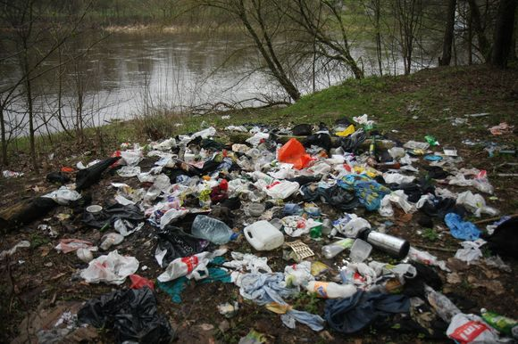

ENGLISH LANGUAGE CONTEST 2015 (FORMS 9–10)

Student B

TASK FOUR: PAIR DISCUSSION

You will be given a picture. You have to respond to the issue represented in the picture and discuss it with a partner. Your partner has the same picture. You have 2 minutes to look at the picture and prepare for the discussion. You are expected to:
- identify the problem / state the issue represented in the picture (Student A);
- exchange opinions with the partner about the issue;
- justify your opinion, provide arguments;
- relate the issue to your own experience or knowledge, give examples;
- summarise and conclude your discussion (Student B).

Note: if you start the discussion, your partner will have to complete the discussion and vice versa.

NO 3.
http://www.15min.lt/naujiena/aktualu/lietuva/uz-netvarka-galima-sulaukti-ir-baudu

ENGLISH LANGUAGE CONTEST 2015 (FORMS 9–10)

Student A

TASK FOUR: PAIR DISCUSSION

You will be given a picture. You have to respond to the issue represented in the picture and discuss it with a partner. Your partner has the same picture. You have 2 minutes to look at the picture and prepare for the discussion. You are expected to:
- identify the problem / state the issue represented in the picture (Student A);
- exchange opinions with the partner about the issue;
- justify your opinion, provide arguments;
- relate the issue to your own experience or knowledge, give examples;
- summarise and conclude your discussion (Student B).

Note: if you start the discussion, your partner will have to complete the discussion and vice versa.

NO 4.
http://www.delfi.lt/news/daily/crime/autobusu-stotelese-siauteja-vandalai.d?id=12288802

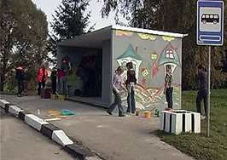

ENGLISH LANGUAGE CONTEST 2015 (FORMS 9–10)

Student B

TASK FOUR: PAIR DISCUSSION

You will be given a picture. You have to respond to the issue represented in the picture and discuss it with a partner. Your partner has the same picture. You have 2 minutes to look at the picture and prepare for the discussion. You are expected to:
- identify the problem / state the issue represented in the picture (Student A);
- exchange opinions with the partner about the issue;
- justify your opinion, provide arguments;
- relate the issue to your own experience or knowledge, give examples;
- summarise and conclude your discussion (Student B).

Note: if you start the discussion, your partner will have to complete the discussion and vice versa.

NO 4.
http://www.delfi.lt/news/daily/crime/autobusu-stotelese-siauteja-vandalai.d?id=12288802

ENGLISH LANGUAGE CONTEST 2015 (FORMS 9–10)

Student A

TASK FOUR: PAIR DISCUSSION

You will be given a picture. You have to respond to the issue represented in the picture and discuss it with a partner. Your partner has the same picture. You have 2 minutes to look at the picture and prepare for the discussion. You are expected to:
- identify the problem / state the issue represented in the picture (Student A);
- exchange opinions with the partner about the issue;
- justify your opinion, provide arguments;
- relate the issue to your own experience or knowledge, give examples;
- summarise and conclude your discussion (Student B).

Note: if you start the discussion, your partner will have to complete the discussion and vice versa.

NO 5.
http://dublinobserver.com/2010/10/cycle-lane-highlights-in-dublin/

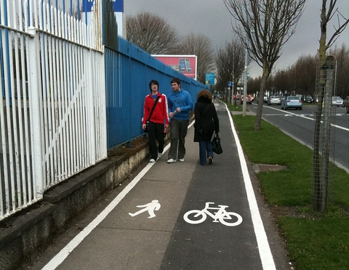

ENGLISH LANGUAGE CONTEST 2015 (FORMS 9–10)

Student B

TASK FOUR: PAIR DISCUSSION

You will be given a picture. You have to respond to the issue represented in the picture and discuss it with a partner. Your partner has the same picture. You have 2 minutes to look at the picture and prepare for the discussion. You are expected to:
- identify the problem / state the issue represented in the picture (Student A);
- exchange opinions with the partner about the issue;
- justify your opinion, provide arguments;
- relate the issue to your own experience or knowledge, give examples;
- summarise and conclude your discussion (Student B).

Note: if you start the discussion, your partner will have to complete the discussion and vice versa.

NO 5.
http://dublinobserver.com/2010/10/cycle-lane-highlights-in-dublin/

ENGLISH LANGUAGE CONTEST 2015 (FORMS 9–10)

Student A

TASK FOUR: PAIR DISCUSSION

You will be given a picture. You have to respond to the issue represented in the picture and discuss it with a partner. Your partner has the same picture. You have 2 minutes to look at the picture and prepare for the discussion. You are expected to:
- identify the problem / state the issue represented in the picture (Student A);
- exchange opinions with the partner about the issue;
- justify your opinion, provide arguments;
- relate the issue to your own experience or knowledge, give examples;
- summarise and conclude your discussion (Student B).

Note: if you start the discussion, your partner will have to complete the discussion and vice versa.

NO 6.
http://www.15min.lt/naujiena/aktualu/lietuva/darom-2013

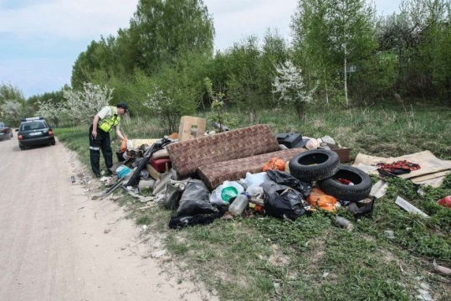

ENGLISH LANGUAGE CONTEST 2015 (FORMS 9–10)

Student B

TASK FOUR: PAIR DISCUSSION

You will be given a picture. You have to respond to the issue represented in the picture and discuss it with a partner. Your partner has the same picture. You have 2 minutes to look at the picture and prepare for the discussion. You are expected to:
- identify the problem / state the issue represented in the picture (Student A);
- exchange opinions with the partner about the issue;
- justify your opinion, provide arguments;
- relate the issue to your own experience or knowledge, give examples;
- summarise and conclude your discussion (Student B).

Note: if you start the discussion, your partner will have to complete the discussion and vice versa.

NO 6.
http://www.15min.lt/naujiena/aktualu/lietuva/darom-2013

