2021 ENGLISH LANGUAGE CONTEST (FORMS 9–10)
PAIR DISCUSSION ASSESSMENT SCALE
CRITERIA |  |  | SCORE | DESCRIPTORS
CONTENT
Opinion, comment (Relevance, coherence, fluency)
3 | All ideas relevant; coherent; easy to follow.
2 | Most ideas relevant; quite coherent; rather easy to follow.
1 | Too few ideas; lack of coherence; may be difficult to follow.
Language resources (Range , clarity, precision)
4 | Wide range of lexico-grammatical structures; the meaning is always clear and precise.
3 | Good range of lexico-grammatical structures; the meaning is always clear and precise.
2 | Adequate range of lexico-grammatical structures; the meaning is generally clear and precise.
1 | Limited range of lexico-grammatical structures; the meaning is often not clear or precise.
DELIVERY
Interaction, cooperation
3 | Excellent use of strategies to initiate discussion and respond to questions; excellent cooperation with the interlocutor.
2 | Good use of strategies to initiate discussion and respond to questions; good cooperation with the interlocutor.
1 | Adequate use of strategies to initiate discussion and respond to questions; adequate cooperation with the interlocutor.
Accuracy
4 | Excellent control of simple and complex language structures; no / minor accuracy errors.
3 | Good control of simple and complex language structures; occassional errors in complex structures.
2 | Adequate handling of simple language structures; problems occur with complex structures.
1 | Poor handling of language structures; problems occur with both complex and simple structures.
Total
(out of 14)

NOTE: Summary by Student A and conclusion by Student B are NOT assessed.

2021 ENGLISH LANGUAGE CONTEST (FORMS 9–10)

PAIR DISCUSSION – 1

You are going to read a news item.

You have to respond to the news and discuss it with a partner.

You have 2 minutes to read the text and prepare for the discussion.

The discussion should take up to 3 minutes.

You are expected to:
- give a short summary of the text (Student A);
- exchange opinions with the partner about the news;
- comment on the events / people described in the text;
- relate the news item to your own experience or knowledge;
- summarise and conclude your discussion (Student B).

Man survives 14 hours 'clinging to sea rubbish'
Vidam Perevertilov spent 14 hours in the water after he fell off the cargo ship into the Pacific Ocean. The 52-year-old, who was not wearing a life jacket, credits his decision to swim towards a "black dot" several kilometres away with saving his life. It turned out to be a fishing buoy, which he held onto until his rescue.
"He looked very tired but he was alive," his son Marat told New Zealand news site. Mr Perevertilov is the Lithuanian chief engineer of the Silver Supporter. Following a shift in the engine room pumping fuel, he felt "hot and dizzy". He walked out onto the deck, before falling off. Unaware that a man had fallen overboard, the ship sailed away.
After struggling to stay afloat, Mr Perevertilov noticed a black speck on the horizon and decided to swim towards it. "It was just a piece of sea rubbish," said Marat.
It took ship crew about six hours to notice that their engineer was missing, at which point the captain turned the ship around. When Mr Perevertilov finally saw his ship in the horizon, he waved and called out. Remarkably, one of the ship's passengers heard the "weak, human shout". A lookout spotted a raised hand later on, and eventually pulled the sailor on board.
"His will to survive was strong... I probably would have drowned straight away, but he always kept himself fit and healthy and that's why I think he could survive," said Marat.

2021 ENGLISH LANGUAGE CONTEST (FORMS 9–10)

PAIR DISCUSSION – 2

You are going to read a news item.

You have to respond to the news and discuss it with a partner.

You have 2 minutes to read the text and prepare for the discussion.

The discussion should take up to 3 minutes.

You are expected to:
- give a short summary of the text (Student A);
- exchange opinions with the partner about the news;
- comment on the events / people described in the text;
- relate the news item to your own experience or knowledge;
- summarise and conclude your discussion (Student B).

China court orders man to pay wife for housework

According to Beijing court, Chen filed for divorce last year from his wife Wang, after getting married in 2015. She was reluctant to a divorce at first, but later requested financial compensation, arguing that Chen had not shouldered any housework or childcare responsibilities for their son. Beijing Court ruled in her favour, ordering him to pay her monthly alimony of 2,000 yuan for the housework she has done.

The ruling was made according to the new civil code in the country, which came into effect this year. Under the new law, a spouse can to seek compensation in a divorce if he or she bears more responsibility in child raising, caring for elderly relatives, and assisting partners in their work.

On social media, the case sparked heated debate, with a related hashtag viewed more than 570 million times. Some social media users pointed out that 50,000 yuan for five years' of work was too little. Others said that men should assume more household duties in the first place.

According to the Organisation for Economic Co-operation and Development (OECD), Chinese women spend nearly four hours a day on unpaid work - roughly 2.5 times that of men. It is higher than the average in OECD countries, where women spend twice the amount of time as men on unpaid work.

2021 ENGLISH LANGUAGE CONTEST (FORMS 9–10)

PAIR DISCUSSION – 3

You are going to read a news item.

You have to respond to the news and discuss it with a partner.

You have 2 minutes to read the text and prepare for the discussion.

The discussion should take up to 3 minutes.

You are expected to:
- give a short summary of the text (Student A);
- exchange opinions with the partner about the news;
- comment on the events / people described in the text;
- relate the news item to your own experience or knowledge;
- summarise and conclude your discussion (Student B).

Some Australian states ease curbs on dancing
Two Australian states will loosen restrictions on dancing at indoor venues and ease other curbs after several weeks of no COVID-19 cases.
In New South Wales, 30 people will be allowed to dance at weddings and 30 people will be able to sing indoors together, up from 5 currently. Households will also be allowed to host 50 guests, up from 30. The move comes after the state had no locally acquired infections for 38th dayd and as the country entered a nationwide vaccination programme. "With the rollout of the vaccine now underway and no new cases, we are able to make further changes," state Premier told reporters.
Restrictions are also being eased in South Australia. Dancing will be now allowed at smaller venues with capacity of less than 200 people, while at bigger venues, 50 can dance at a time at a designated area.
The state will also drop testing requirements for visitors from Melbourne. Although there have been cases among returning citizens from abroad, Australia has largely contained community transmission of the virus with mandatory mask-wearing on public transport and snap lockdowns.

2021 ENGLISH LANGUAGE CONTEST (FORMS 9–10)

PAIR DISCUSSION – 4

You are going to read a news item.

You have to respond to the news and discuss it with a partner.

You have 2 minutes to read the text and prepare for the discussion.

The discussion should take up to 3 minutes.

You are expected to:
- give a short summary of the text (Student A);
- exchange opinions with the partner about the news;
- comment on the events / people described in the text;
- relate the news item to your own experience or knowledge;
- summarise and conclude your discussion (Student B).

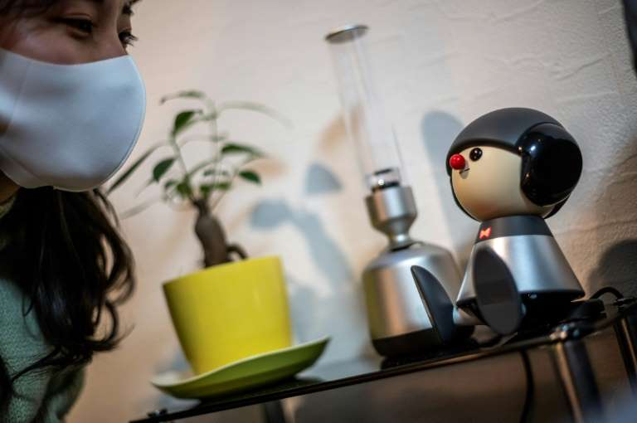 Hi, Robot: Japan's android pets ease virus isolation

Nami Hamaura says she feels less lonely working from home thanks to her singing companion Charlie, one of a new generation of cute and clever Japanese robots whose sales are booming in the pandemic. Technology firms in Japan are reporting huge demand for humanlike robots, as people seek companionship during isolation.

"I felt my circle became very small," Hamaura, who has worked remotely since April 2020. With socialising limited, her first job is nothing like she imagined when she was a student. So she adopted Charlie, a mug-sized robot with a round head, red nose and flashing bow-tie, who converses with its owner in song. "He is there for me to chat with as someone other than family, or friends on social networks," Hamaura said.

"Charlie, tell me something interesting," she asks while typing at her dining table. "Well, well... balloons burst when you spray lemon juice!" he replies in a singing voice, cheerfully tilting his head to each side.

Among other robot pets offered by Japanese manufacturers are Robohon, which talks, dances and is also a working phone; Qoobo, a fluffy pillow with a mechanical tail that wiggles like a real pet; and Lovot, a robot the size of a small toddler, with big round eyes and penguin-like wings that flutter up and down.

In Japan, robots feel normal in everyday life because they are in so many Japanese children's films and cartoons.

2021 ENGLISH LANGUAGE CONTEST (FORMS 9–10)

PAIR DISCUSSION – 5

You are going to read a news item.

You have to respond to the news and discuss it with a partner.

You have 2 minutes to read the text and prepare for the discussion.

The discussion should take up to 3 minutes.

You are expected to:
- give a short summary of the text (Student A);
- exchange opinions with the partner about the news;
- comment on the events / people described in the text;
- relate the news item to your own experience or knowledge;
- summarise and conclude your discussion (Student B).

LRT launches English language podcast – Culture Nerve

LRT RADIO is launching the first English-language podcast, Culture Nerve.

In each bi-weekly episode, a Lithuanian and a foreign expert will sit down for a virtual talk to share their thoughts on what matters most in culture. This podcast is created together with the network of Lithuania’s cultural attachés in foreign countries.

“The Lithuanian cultural attachés wish to contribute even more to the creation of LRT’s cultural content. Our cultural professionals maintain extensive international relations: they constantly encounter interesting people from the world of culture whose ideas do not always reach Lithuania,” said Juta Liutkevičiūtė-Kiudė, host of the podcast.

“Their valuable conversations about society, culture in general, and remarkably similar or radically different contexts – depending on the country – often remain in closed circles; thus, the Lithuanian cultural attachés suggested that we create this type of podcast. The main idea of Culture Nerve is to stimulate discussion about culture and art among different countries”.

In the first episode, Italian professor Roberto Farneti meets historian and diplomat professor Irena Vaišvilaitė to discuss what the Soviet and fascist regimes have left behind in their native countries and how to deal with difficult historical events and their legacy in different countries.

All episodes will be available to listen on LRT’s Audioteka, LRT English, and on Spotify.

